Personal care

My mum/dad/carer wakes me up.

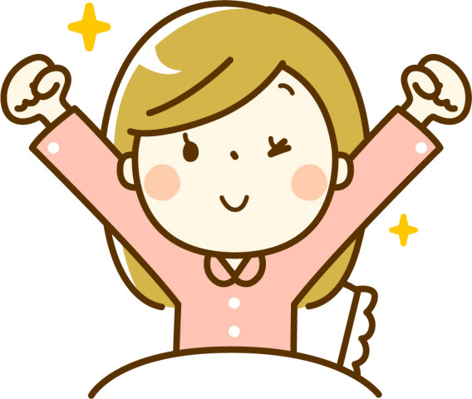

My mum/dad/carer helps me get dressed.

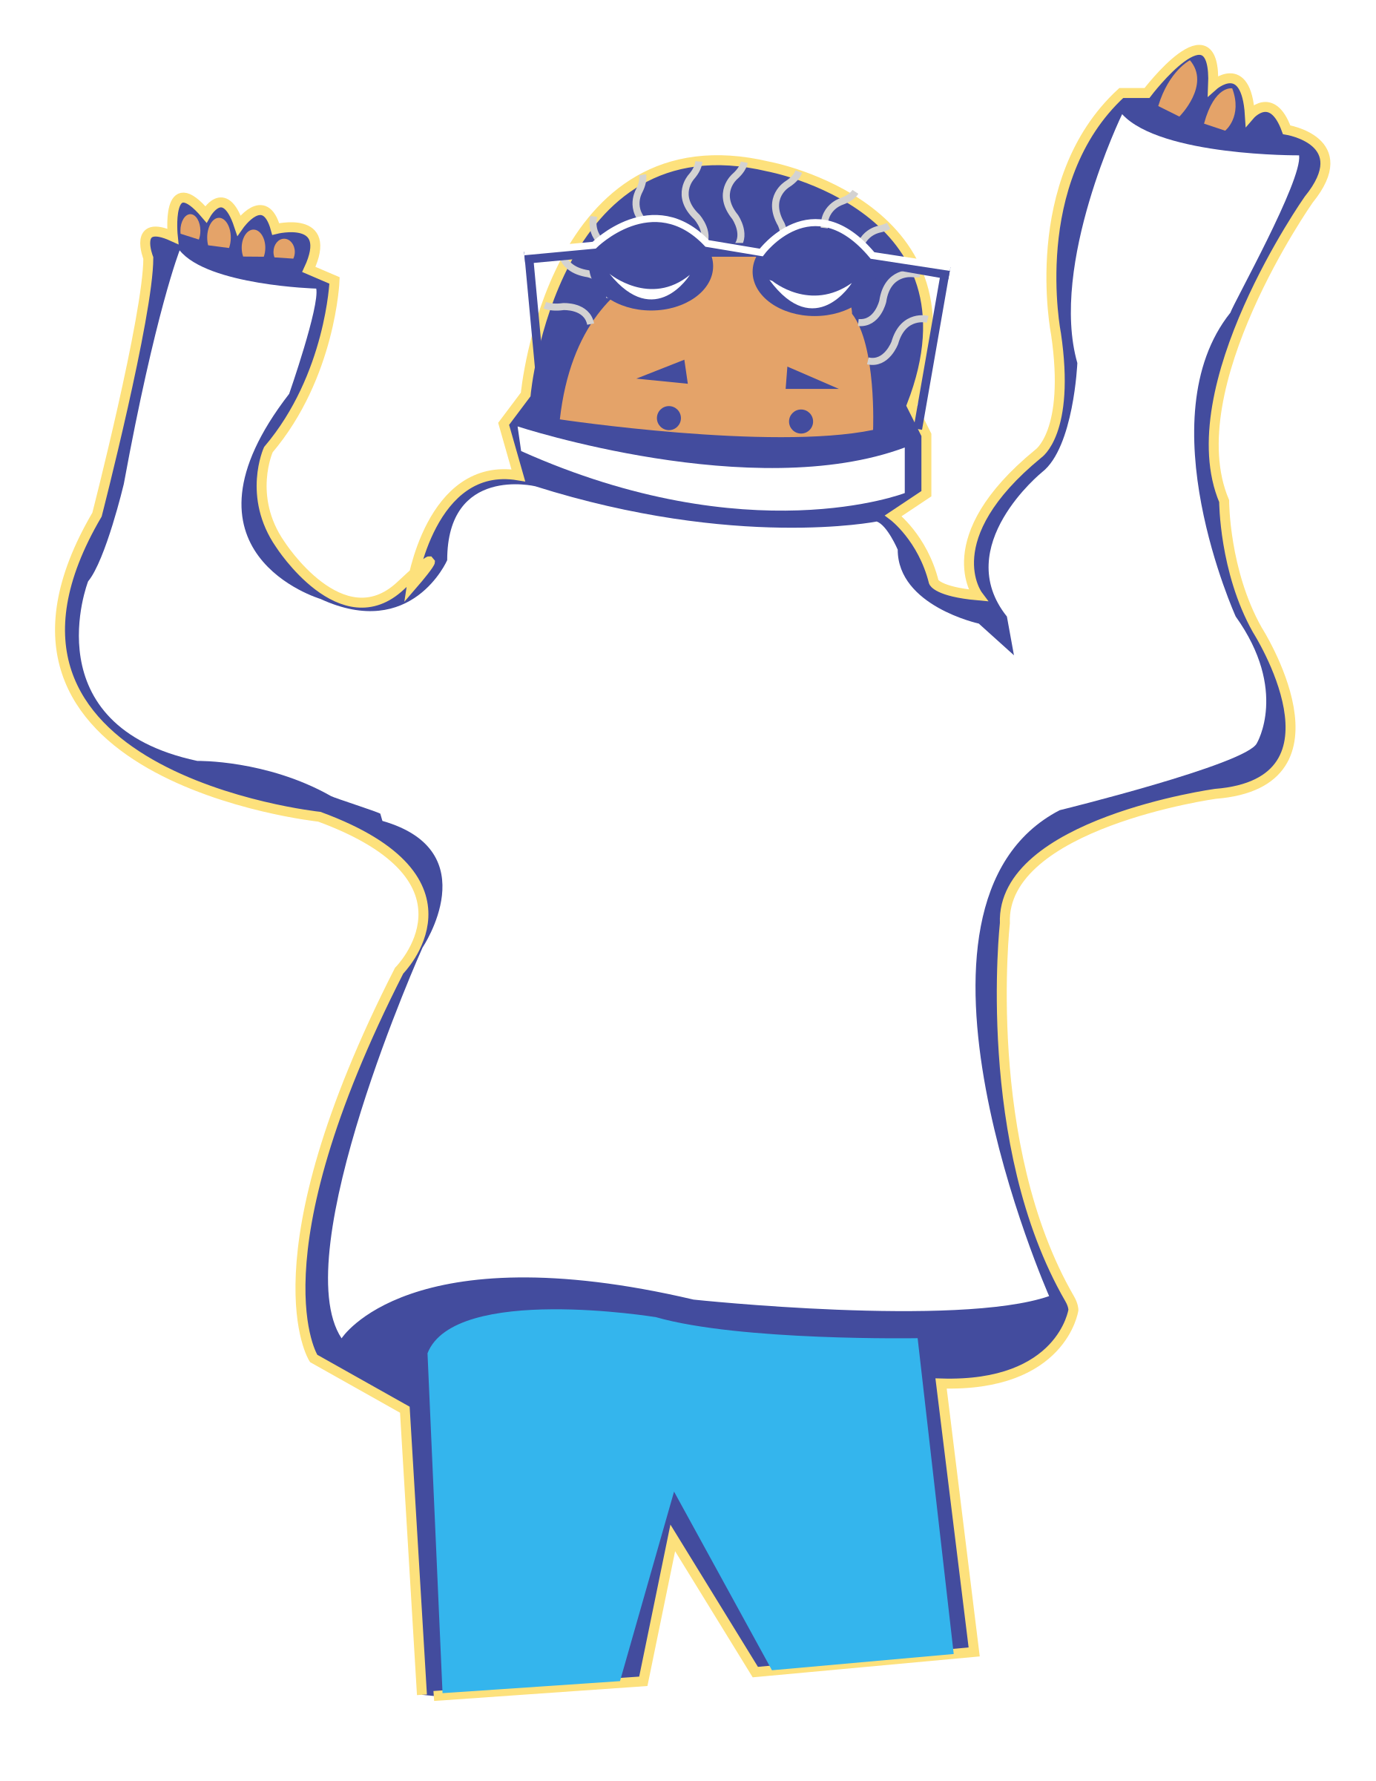

I have a bath or shower. My mum/dad/carer helps me wash.

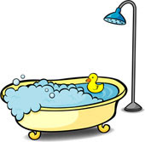

My mum/dad/carer brushes my teeth.

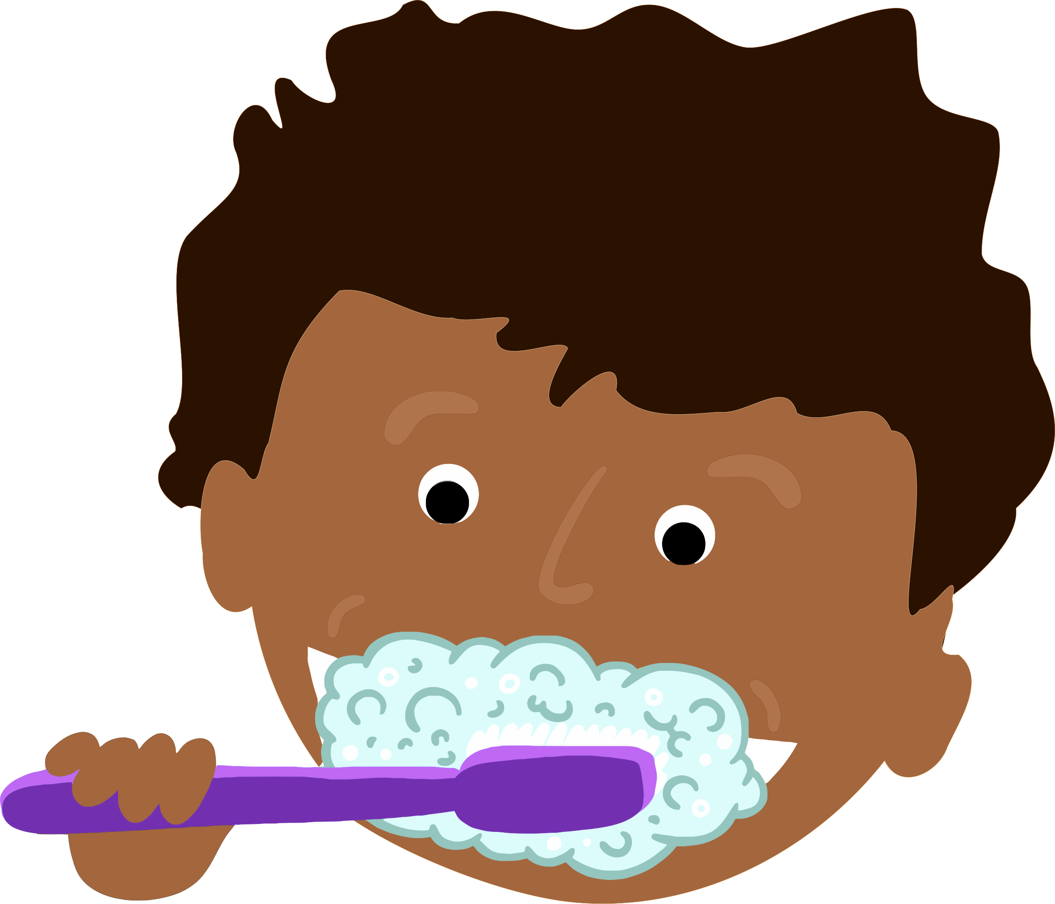

My clothes are clean.

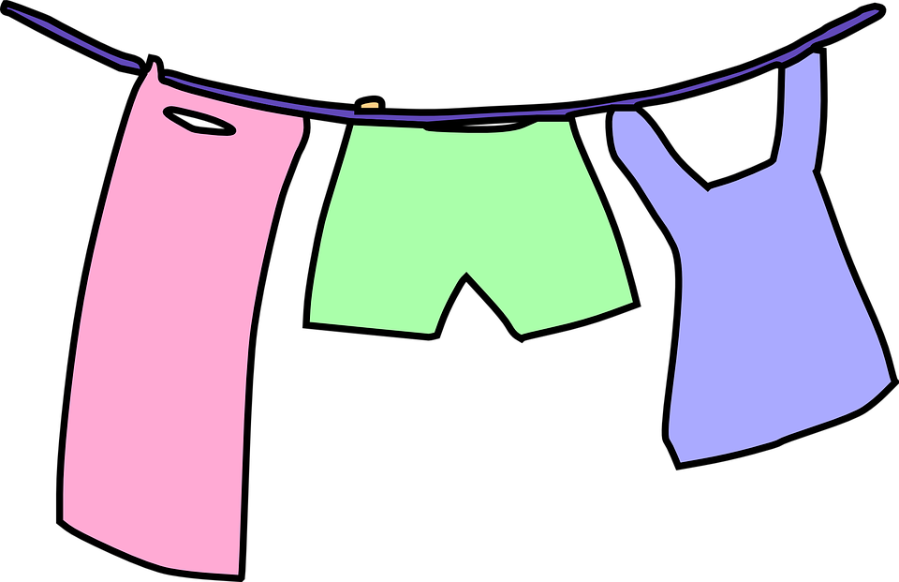

I have enough clothes and they fit me.

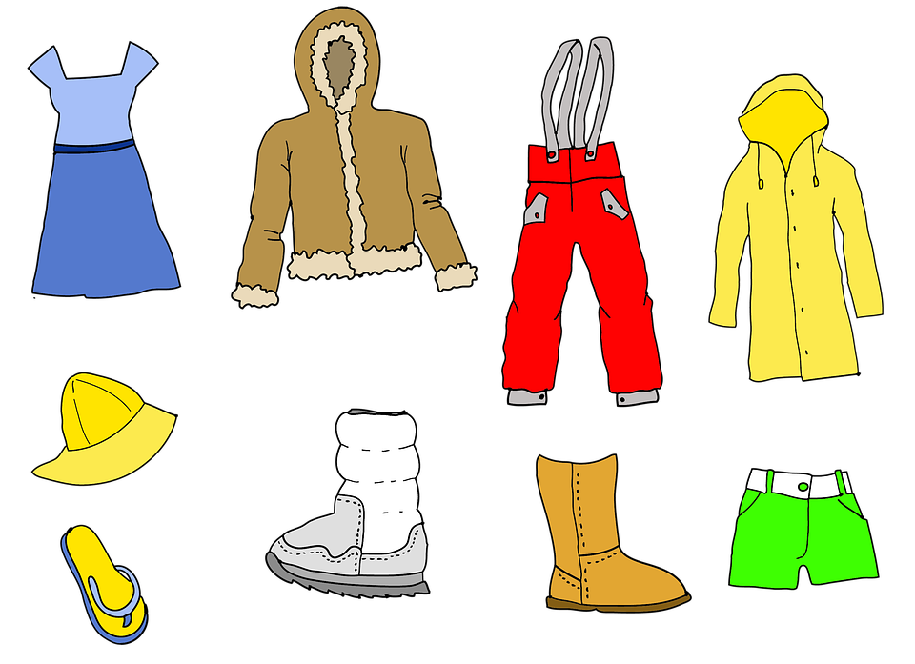

My bed is warm.

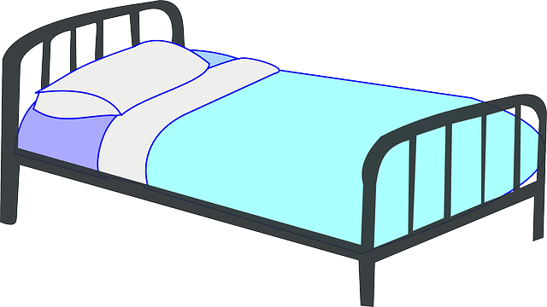

My bedding is washed and clean.

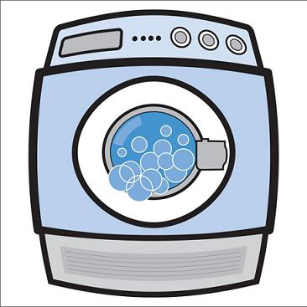

Mealtimes

I have a hot dinner at home.

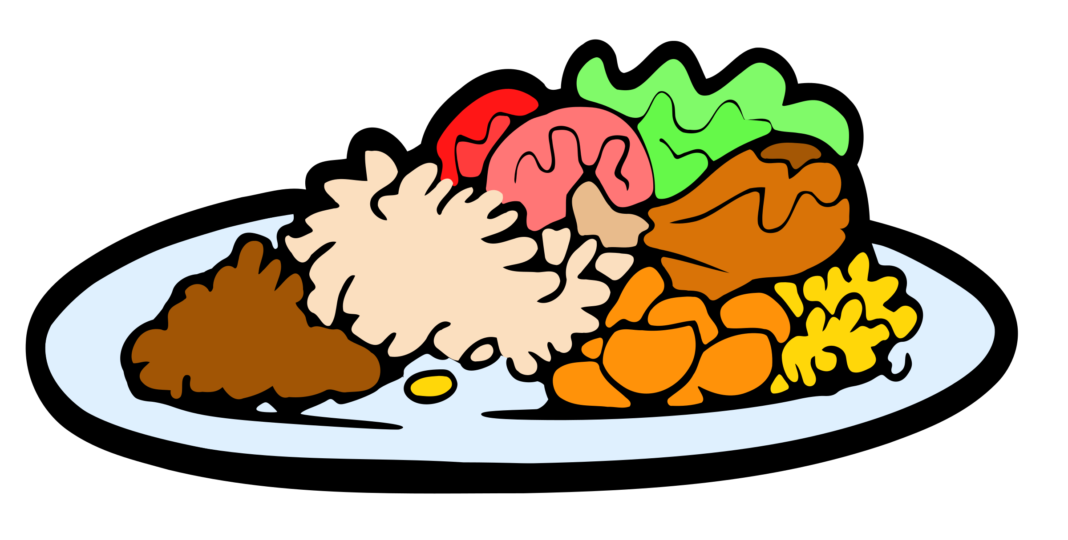

There is breakfast at home and I eat breakfast.

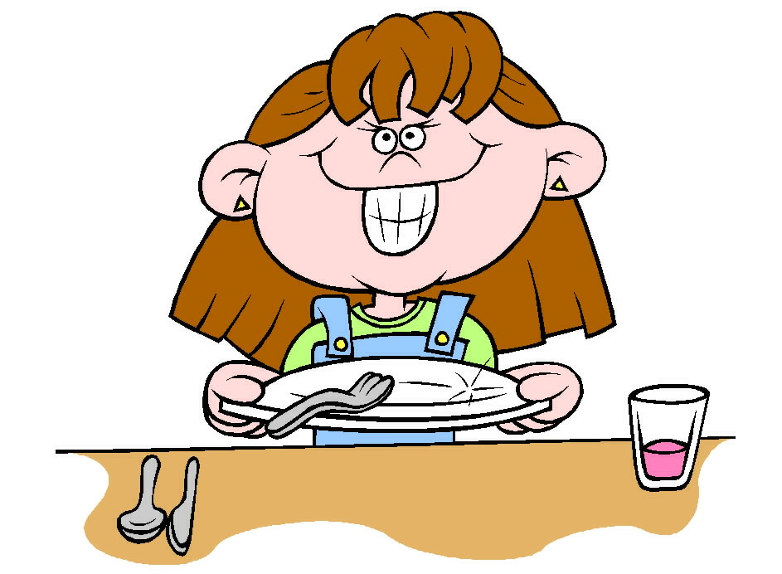

I have enough food on my plate so I am not hungry.



My mum/dad/carer makes me breakfast and dinner.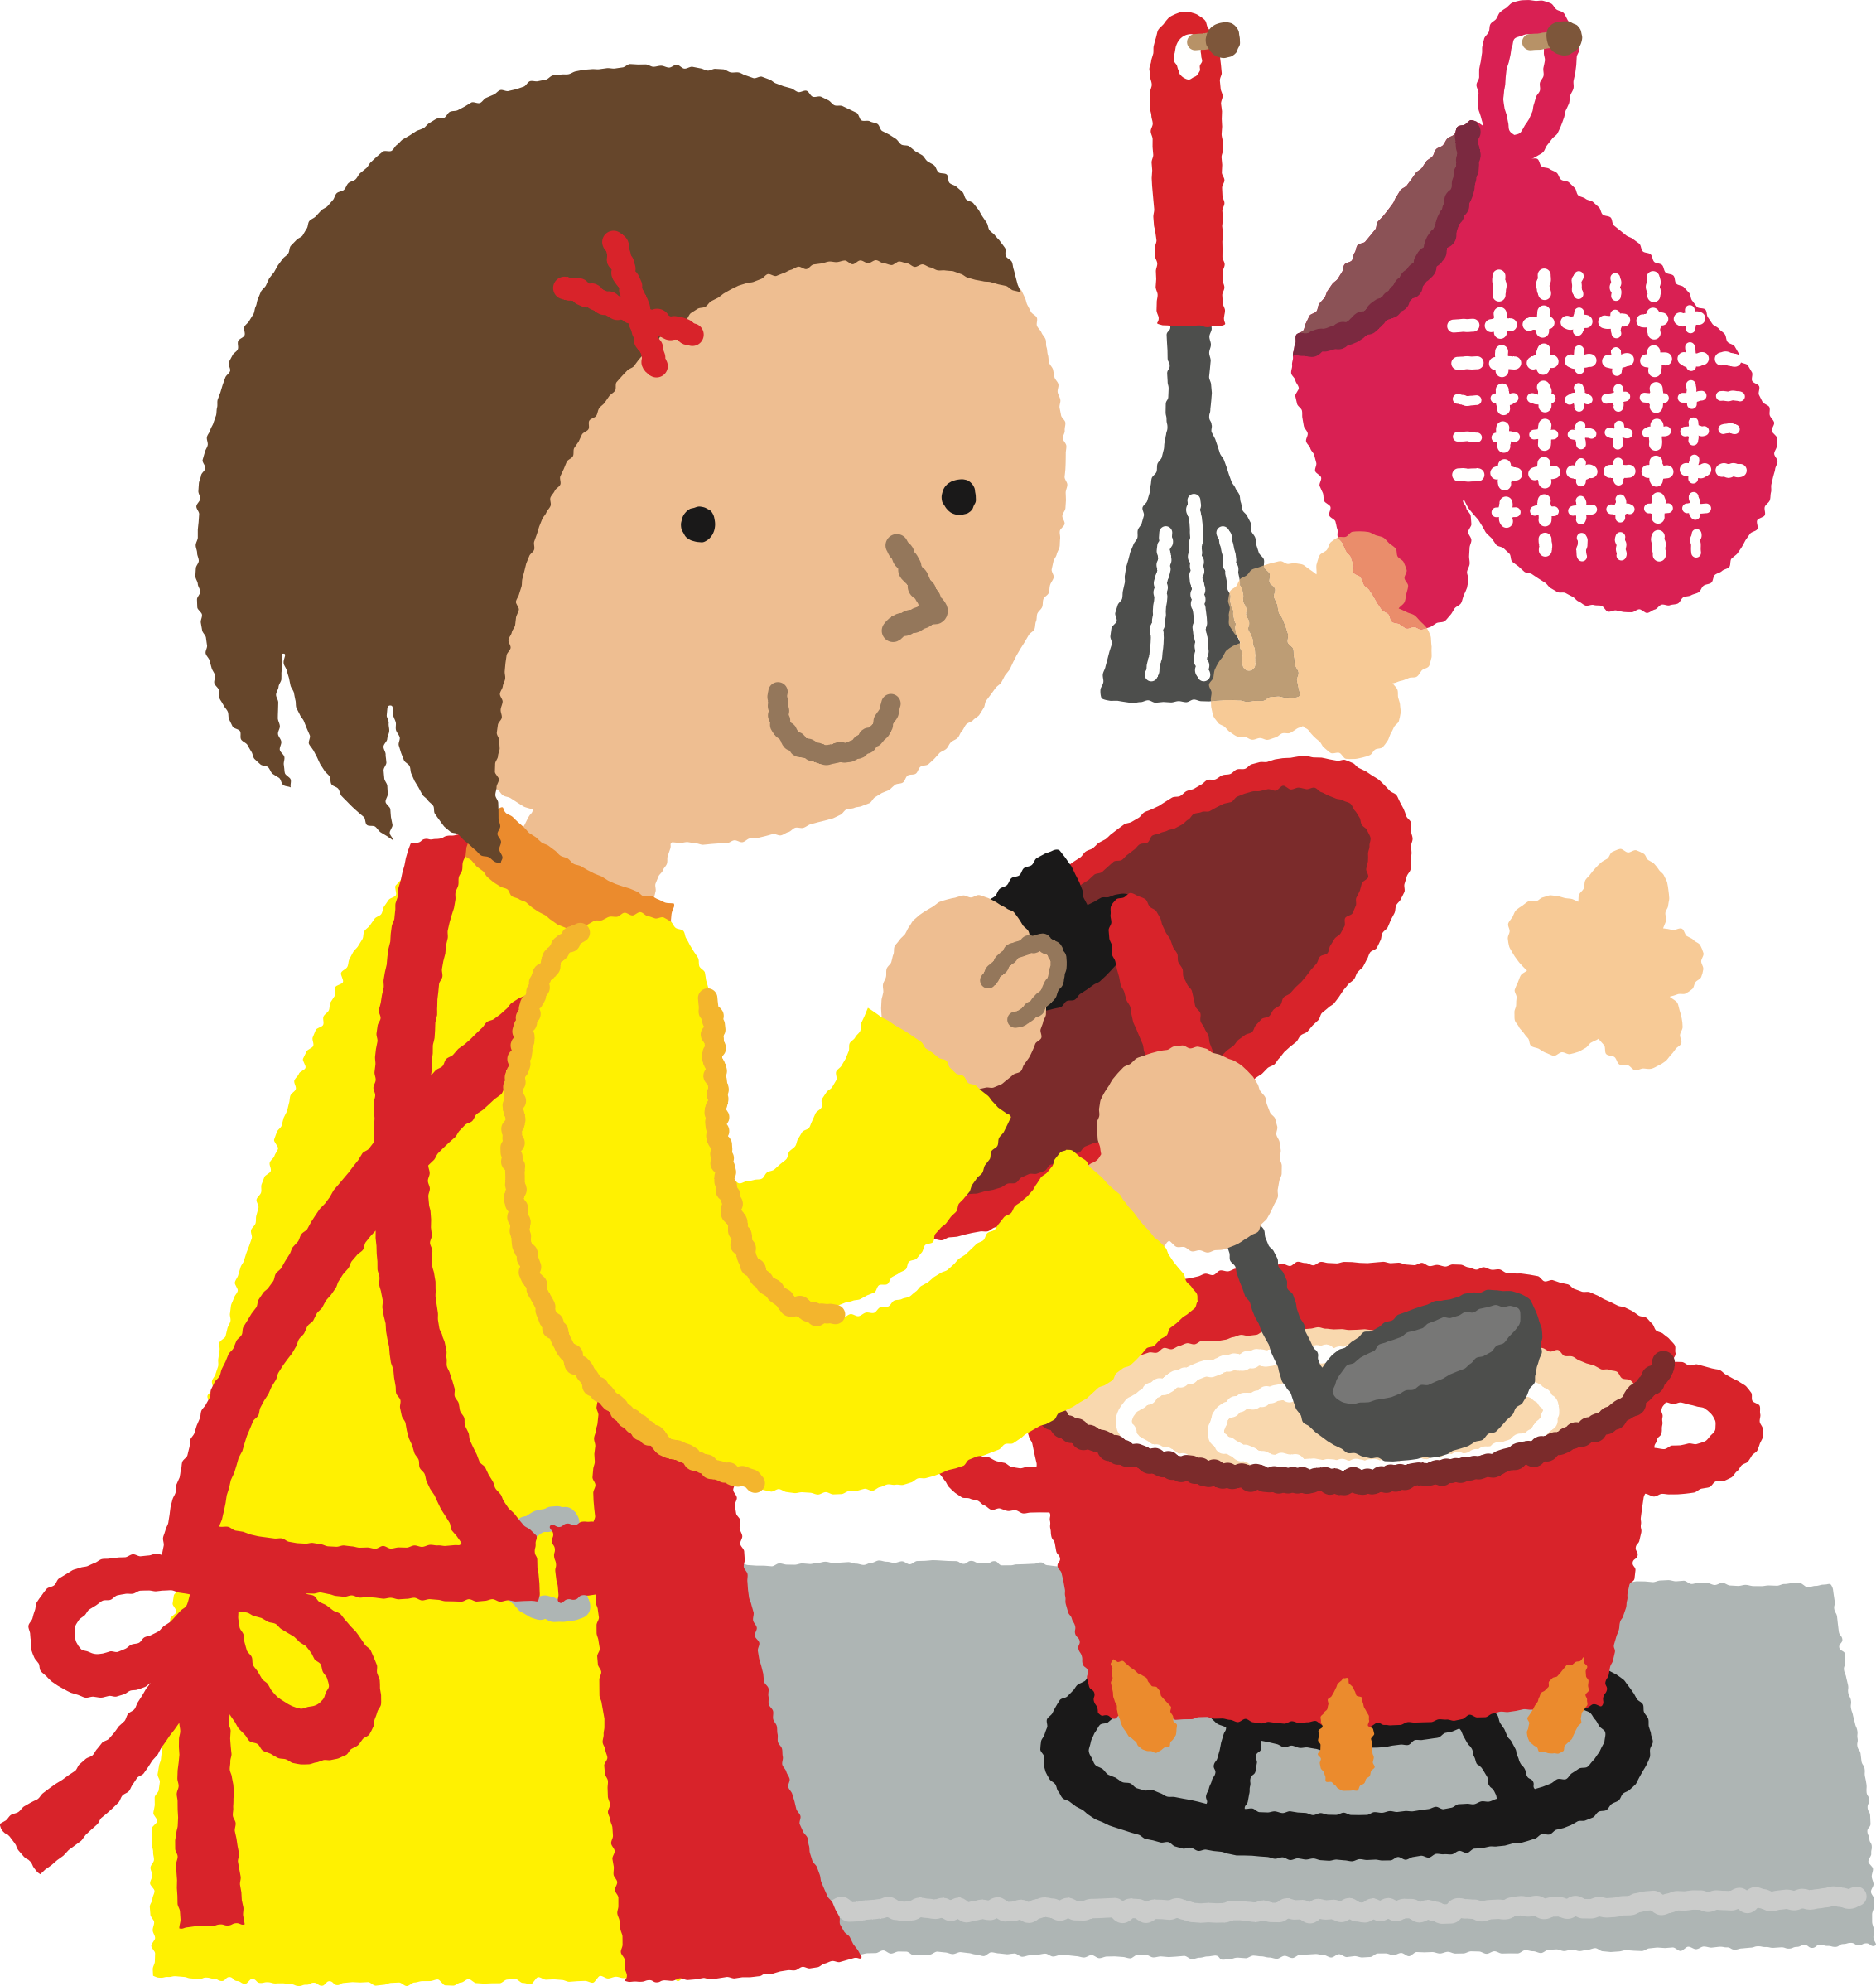

Love and affection

My siblings love me.



My mum/dad/carer loves me.



I see my grandparents, aunties, uncles, cousins and other people in my family.

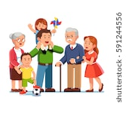

My mum/dad/carer hugs and kisses me and says nice things.

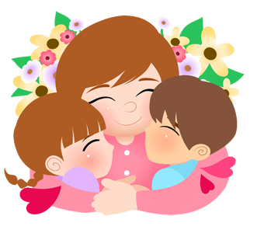

Supervision

People I don’t know come to my house.



I am at home on my own.



I have to look after my siblings.

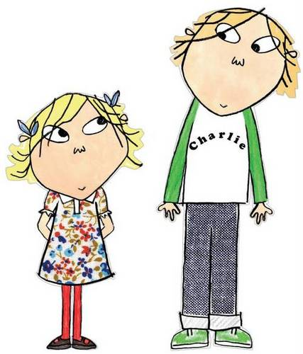

People other than my mum/dad/carer look after me.

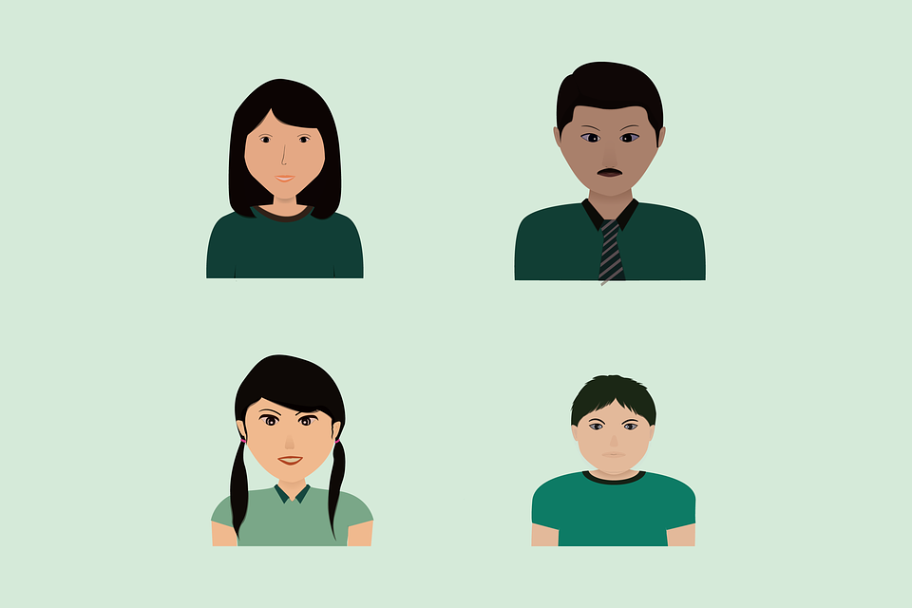

School

I am happy at school.

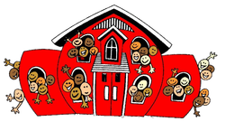

I am at school on time.

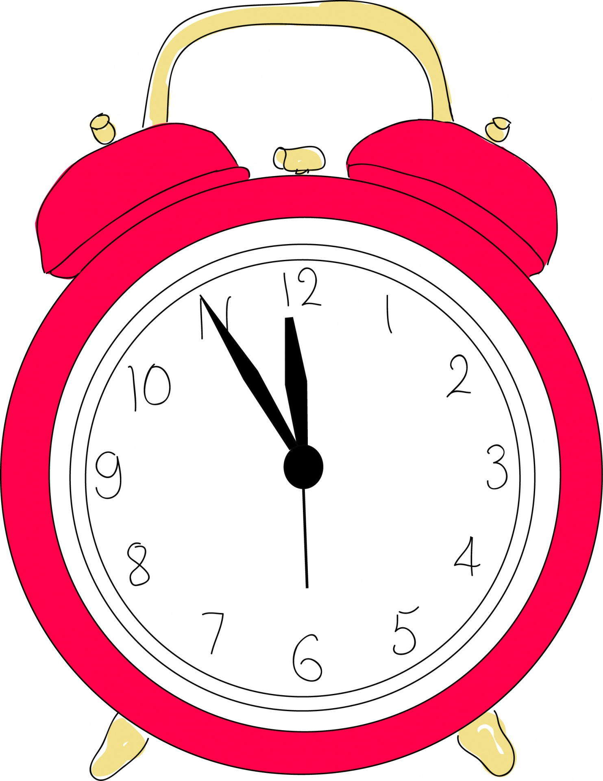

I have a packed lunch or school lunch.

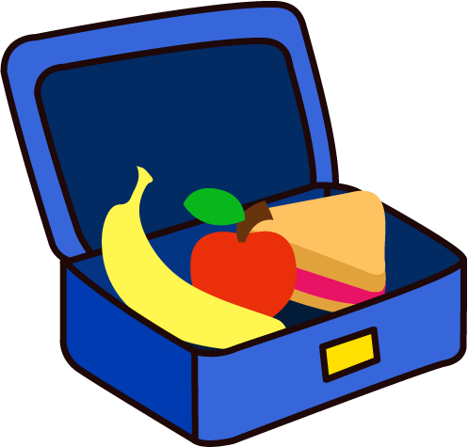

I have friends at school.

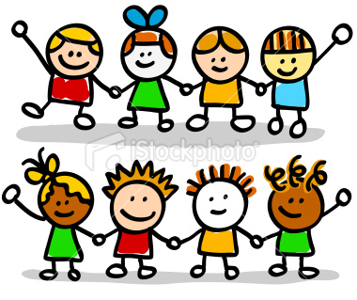

After school

I play with toys and games with my mum/dad/carer/siblings.

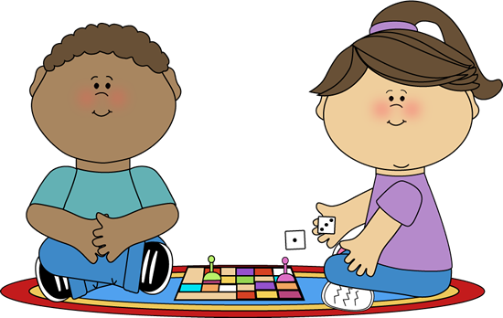

I watch TV or play on a games console.



I go to an after-school club or have a hobby.

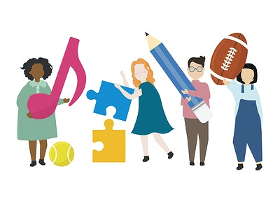

I have help with my homework.

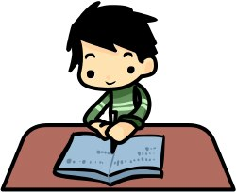

My family are at home after school.



I watch YouTube.



My mum/dad/carer puts my pyjamas on.

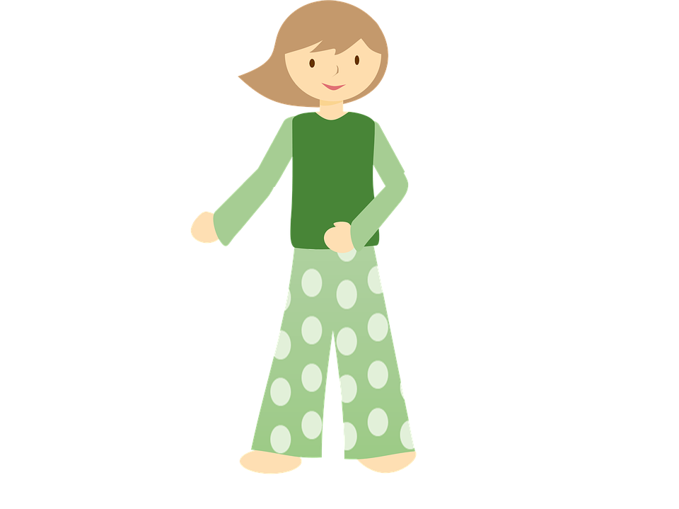

I go to bed the same time every night.

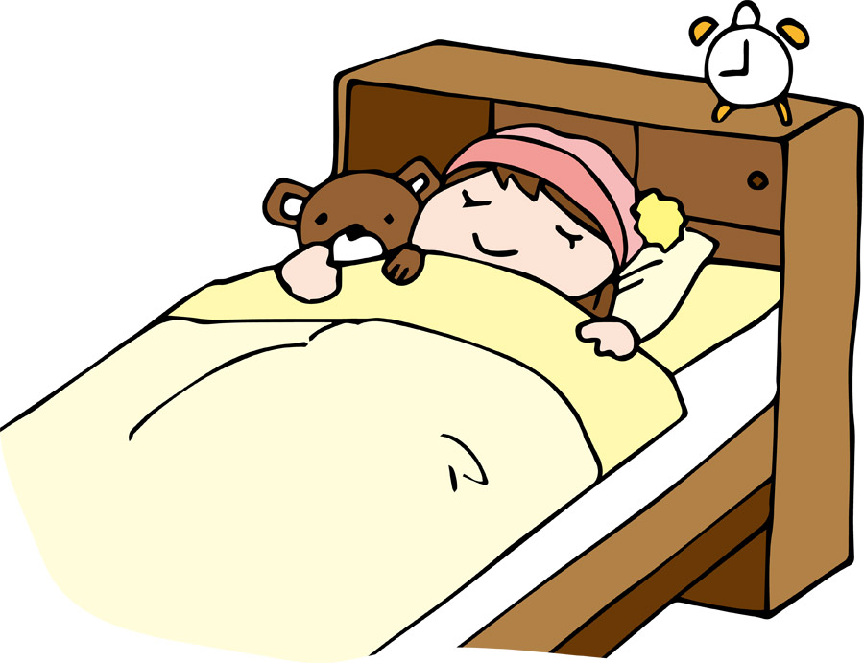

My mum/dad/carer puts me to bed.

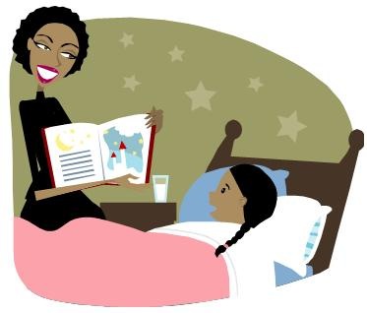

Medical

I see the doctor if I don’t feel well.

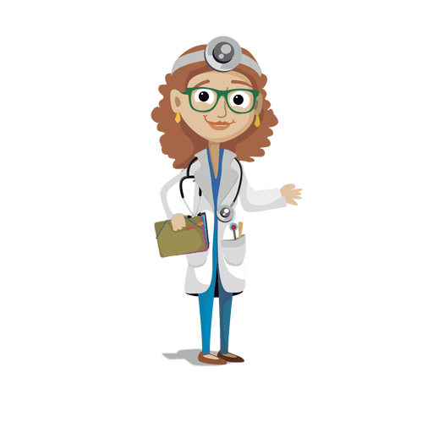

I go to the dentist.

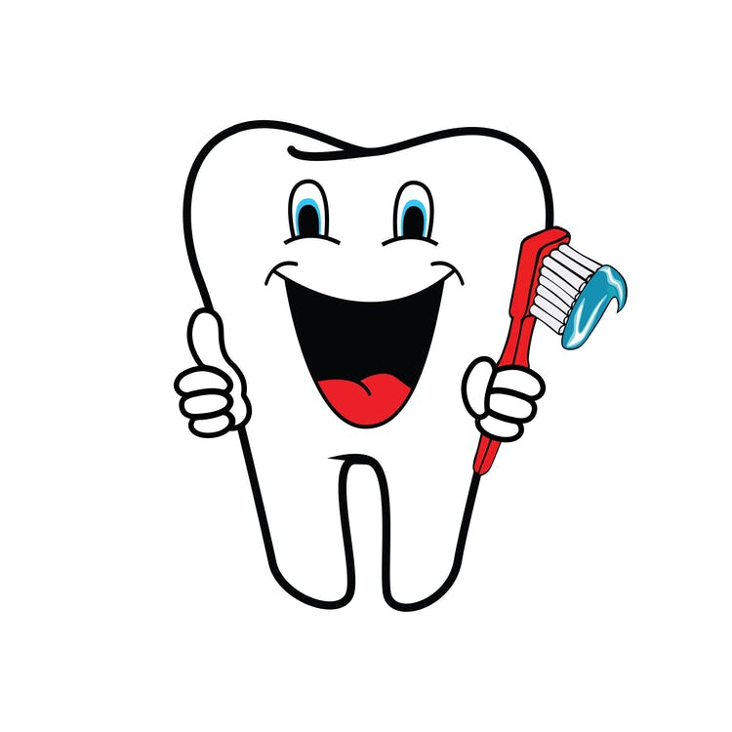

I have medicine if I am poorly.

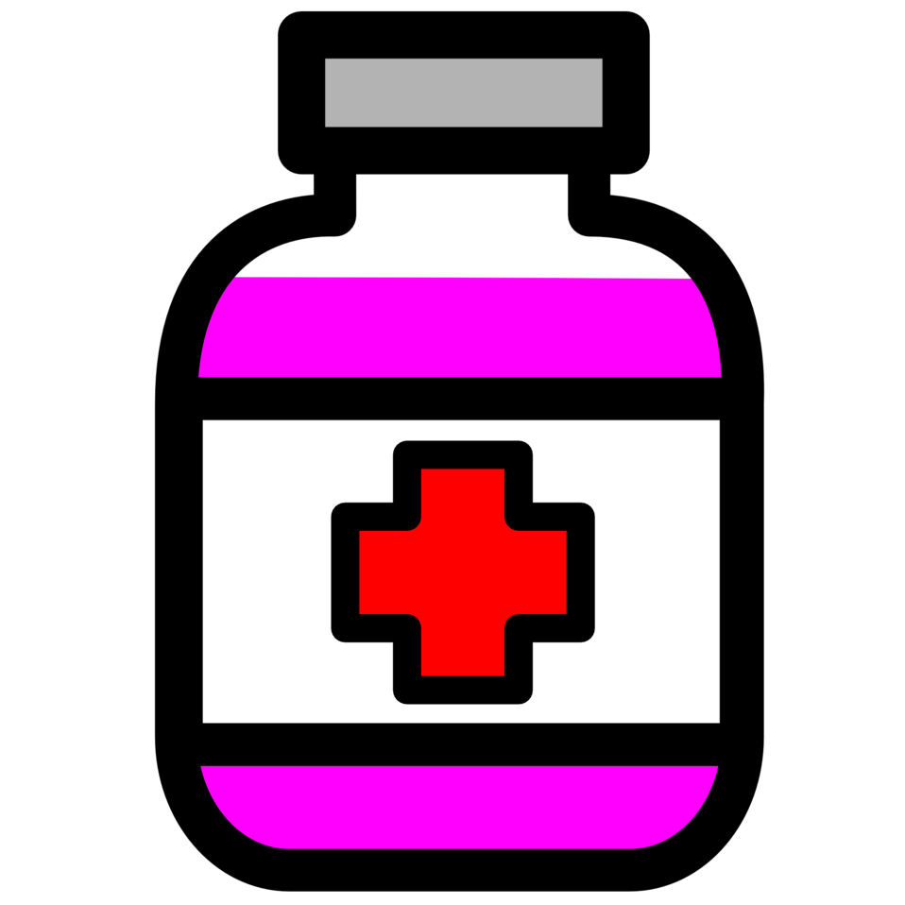

Summer holidays/weekends

I go out with my mum/dad/carers and siblings at weekends and in the holidays.

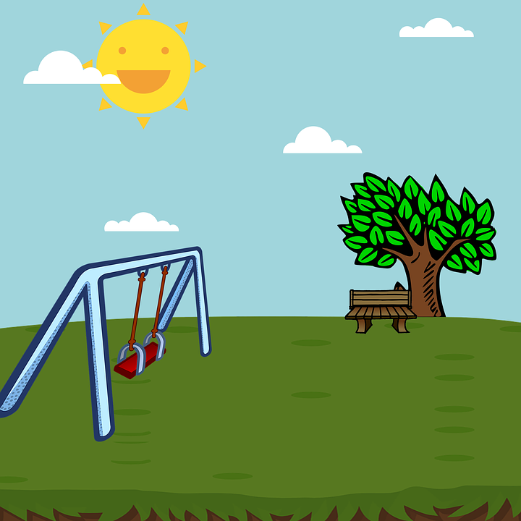

I see my friends outside of school.

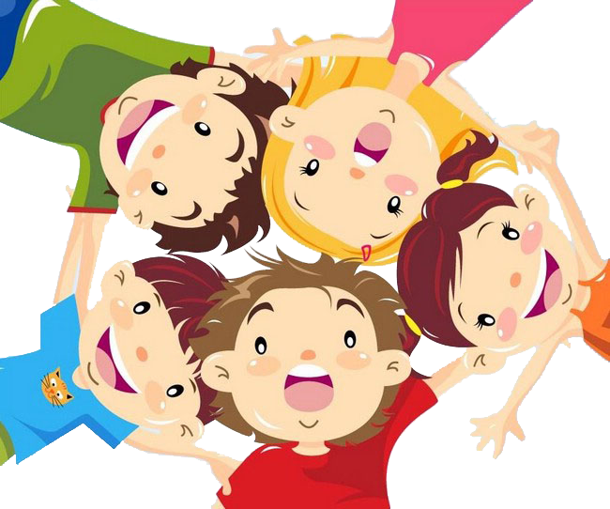

I have chores to do at home.

