Multi-Agency Self Neglect and Hoarding

Policy and Practitioner Guidance

Version control | V1.0 |  | Review date | January 2023

This Policy has been developed in partnership with Worcestershire Safeguarding Adults Board.
This document includes Herefordshire pathways

Introduction and Purpose

  - This document provides guidance for practitioners whose role may bring them into contact with individuals, who persistently self-neglect or engage in hoarding behaviours that place them at risk of significant harm. When practitioners fail to find ways to engage with an individual at risk of self-neglect, there may be serious implications for that person’s health and wellbeing. If professionals are unable to engage the person with support, and this is likely to result in significant harm, a safeguarding enquiry under S42 of the Care Act 2014 is required. This situation is most likely to occur when the individual at risk from self-neglect has capacity to make and enact decisions related to their wellbeing and is unable to take self-protective action by controlling their own behaviour.If the circumstances do not trigger a safeguarding concern, it is likely that they will trigger a duty to compete an assessment of care and support needs. Balancing the duty to protect the individual from significant harm with the duty to respect their freedom of choice can be both stressful and challenging for practitioners. This guidance aims to support good practice and establishes a multi-agency pathway to provide support for those individuals who do not recognise the impact of or fail to take action to address the risks arising from self-neglect. Central to this is a ‘no wrong door’ approach, whereby every contact is seen as an opportunity for intervention and all agencies work with the person rather than referring them elsewhere.

  - Analysis of 2017 - 2019 Safeguarding Adults Reviews (SARs) identified self-neglect as the most frequent reason for a case to be referred for a SAR, with self-neglect being identified as a type of abuse and neglect in 45% of SARs. The findings in Herefordshire show all local SARs have an element of self-neglect or hoarding. The analysis cited application of the Mental Capacity Act 2005, risk assessment, assessment of needs and responding to health needs as practice areas most frequently found to need improvement. Assumption of capacity without further exploration of whether the individual can take practical steps to resolve their situation has also been a feature in SARs conducted within Herefordshire. There has also been an identified need for a nominated practitioner to coordinate and facilitate multi-agency working.

This policy applies to all practitioners whether salaried or volunteers, in all settings across Herefordshire who come into contact with people who self-neglect.

Nb: all items in blue are hyperlinks to the relevant information cited in the document

Definitions

  - The Care and Support Statutory guidance 2020 states that self-neglect ‘… covers a wide range of behaviour neglecting to care for one’s personal hygiene, health or surroundings and includes behaviour such as hoarding’ but does not give specific details. Care Act statutory guidance – safeguarding

  - Self-neglect typically features a triad of behaviours –
    - Lack of self-care to an extent that it threatens their personal health and safety.
    - Failure to attend to their living environment to the extent that it becomes hazardous to self or others e.g. fire risk, infestation, lack of sanitation.
    - Failure to seek help or access services to meet their critical health and social care needs.

  - The person may present with a compulsion to accumulate belongings or animals. The term hoarding should be used sensitively as the person may place a high emotional value on these items. SCIE self-neglect at a glance

  - Self-neglect can be a complex and challenging issue for practitioners to address, not least because of difficulties in striking a balance between respecting a person's right to autonomy and fulfilling the statutory duty of care to protect their health and wellbeing. This policy directs practitioners to utilise a multi-agency approach to ensure they have the right support and expertise to draw on to address the specific presenting issues.

  - Hoarding behaviours are strongly associated with self-neglect. A hoarding disorder is where an individual acquires an excessive number of items and stores them in a chaotic manner, usually resulting in unmanageable collections of items often having little or no monetary value. Hoarding behaviours can cause significant problems if parts of an individual’s home become unusable, particularly kitchens or bathrooms; if it becomes impossible for them to maintain adequate cleaning increasing the risk of vermin or unhygienic conditions; if it prevents easy access / exit of the property in the event of a fire or other emergencies; or if the clutter is negatively affecting the quality of life of the person, neighbours or wider public. As hoarding is a disorder, the person should be described as presenting with hoarding behaviour, not as a hoarder.

  - Many people who hoard have strongly held beliefs related to acquiring and discarding things, such as: "I may need this someday" or "If I buy this, it will make me happy". Others may be struggling to cope with a stressful life event, such as the death of a loved one. Attempts to discard things often bring up very strong emotions that can feel overwhelming, so the person often tends to put off or avoid making decisions about what can be thrown out. Most people with a hoarding disorder have a very strong emotional attachment to the objects so respectful terminology must be used e.g. ‘belongings’ not ‘clutter’.

  - To ensure practitioners get an accurate sense of a clutter problem it is recommended that the clutter image rating is used. This series of pictures of rooms in various stages of clutter, from completely clutter-free to very severely cluttered, allows for a common view across a multi-agency fora. In general, clutter that reaches the level of picture # 4 or higher impinges enough on people’s lives that we would encourage them to get help for their hoarding problem. (See illustrations at Appendix 2).

  - Self-neglect is also often associated with people who are homeless and those who sleep rough. There is some evidence of a reluctance to see the situation of these people as a safeguarding concern or to see people’s situations as anything other than a housing matter and to assess their care and support needs accordingly. When supporting people who are homeless and those who sleep rough it is important for agencies to cooperate, for hospital discharge arrangements to be robust and for there to be supported accommodation available.

  - In this policy, the term practitioners refers to anybody working with a person who may be neglecting themselves. This includes paid staff and volunteers such as those working as Street Pastors or in soup kitchens.

The Legal Framework

  - There are two pieces of primary legislation which provide the framework for responding to self-neglect.

  - The Care Act 2014 sets out the local authority’s powers and duties towards adults with care and support needs and provides the statutory framework for safeguarding adults. The Care and Support Statutory Guidance which supports the Care Act 2014 includes self-neglect as a category of abuse and neglect linking self-neglect to statutory safeguarding duties.

However, in relation to self-neglect, the Care and Support Statutory Guidance acknowledges that:

“It should be noted that self-neglect may not prompt a section 42 enquiry. An assessment should be made on a case by case basis. A decision on whether a response is required under safeguarding will depend on the adult’s ability to protect themselves by controlling their own behaviour. There may come a point when they are no longer able to do this, without external support.”

Therefore, self-neglect does not always require a safeguarding response, ‘there is a fine balance to be struck regarding proportionality. The right of the individual to take risks balanced against the duty to protect health and wellbeing.’

  - The Mental Capacity Act 2005 provides the principle that a person must be assumed to have capacity to make a decision, even if that decision appears eccentric or unwise, unless an assessment using criteria set out in the Act has shown that they lack capacity.

3.4 It is important to consider the Human Rights Act 1998 remember that the use of legal powers and duties must comply with the European Convention on Human Rights, along with the principle of proportionality and procedural safeguards in circumstances where rights may be infringed. The rights most relevant when working with people at risk of self-neglect are Article 2 (right to life), Article 3 (protection from inhuman and degrading treatment, Article 5 (protection of liberty and personal security) and Article 8 (respect for private and family life). Any interference with human rights must be lawful, in other words permitted by statute and proportionate to the level of risk. The Equality Act 2010 sets out the public sector equality duty requiring consideration of protected characteristics.

Making Safeguarding Personal and Strengths-based Practice

4.1 The Care and Support Statutory Guidance, the Strengths-based Practice Framework and Making Safeguarding Personal have set out guiding principles to consider when engaging with individuals who may self-neglect or hoard:

  - Start with the assumption that the individual is best placed to judge their wellbeing.
  - Pay close attention to individual’s views, wishes, feelings and beliefs.
  - Preventing or delaying development of needs for care and support and reducing needs that exist.
  - The need to protect people from abuse and neglect.

These principles enable practitioners to work in line with strengths-based practice and Making Safeguarding Personal. This ensures that work undertaken with people who self-neglect is outcome focused, is in line with the person’s wishes rather than being process driven, and puts involvement of the person at the heart of intervention; ‘Nothing about me, without me.’
4.2 Many Safeguarding Adult Reviews have highlighted how respect for ‘choice’ has meant that professionals supporting a person who self-neglects may simply withdraw when asked. A strengths-based approach may be seen as putting great emphasis on the person’s wishes, leading to no support being offered. Professor Michael Preston-Shoot has written about this tension, suggesting that we should not regard a person's “lifestyle choice” as representing a strength if they do not see how things could be different or the person may have very low self-esteem. Additionally, a person’s lifestyle should not necessarily be seen as chosen and within their control, particularly if they have been affected by ill-health, substance abuse or mild cognitive impairment. He suggests asking ‘care-full’ questions to help you to understand how the person feels and the extent to which their situation genuinely reflects their choices and control. Being person-centred can be about exploring alternatives and challenge. Be aware of contradictions, of once-intended change not being fulfilled and reflect these back to the person. In this way the response will be person-centred without acting simply on their response to offers of practical assistance.

Causes

  - Understanding the person’s ‘story’ and how they came to be in their current situation is critical to supporting them to move on from self-neglect. This also helps to make sense of seemingly unwise or inconsistent responses to offers of help.

  - It is not always possible to establish a root cause for self-neglecting behaviours, but there is correlation with –

    - poor mental health, particularly depression and obsessive-compulsive disorder and cognitive decline due to Alzheimer’s disease or dementia
    - physical illness which affects abilities, energy levels, attention span, organisational skills or motivation
    - addictions
    - learning disabilities (including autism)
    - acquired brain injuries
    - trauma, loss and difficulties in managing transitions in lifestyles or phases
    - exploitation (cuckooing, ‘mate’ crime etc.)
    - hoarding behaviours

  - Sometimes self-neglect is related to deteriorating health and ability in older age and the term ‘Diogenes syndrome’ may be used to describe this. There is evidence to suggest that the risk of self-neglect increases with diminishing social networks and financial hardship, which may be associated with aging.

  - Self-neglect may also arise from a once functional behaviour becoming problematic (e.g. storing large amounts of tinned goods as a safeguard against shortages), personal values (e.g. belief in self-sufficiency, pride, mistrust of professionals) or in the case of accumulating possessions, a desire to maintain a sense of continuity or connectedness with people or past events.

  - Self-neglect is an issue which disproportionately effects people who have or are currently experiencing homelessness and those who are sleeping rough (including experience of temporary/unsuitable accommodation). Self-neglect can also occur in people who have experienced multiple areas of social exclusion such as time spent in institutional care (prison, local authority care, psychiatric wards); substance misuse; or participation in street culture activities such as begging, street drinking, survival shoplifting or sex work. Most people experiencing multiple exclusion and/or homelessness also face significantly increased risk of abuse, exploitation and neglect as well as poor health and reduced life expectancy. Trauma and loss are also a key feature in local SARs, especially in relation to people who are rough sleeping.

Figure 1. Key factors in self-neglect

Figure 1: Diagram showing the main contributing factors for self-neglect; hoarding behaviours, learning disabilities, poor mental health, addictions, poor physical health, trauma and loss, isolation, acquired brain injuries, exploitation and environment.

Engaging with the person

  - Attempts to address self-neglect will not succeed unless practitioners have first formed a degree of trust with the person. This is best achieved through ensuring there is a consistent practitioner who is committed to this work and who is supported by their agency to invest the necessary time to work with them.

  - Initial engagement needs to focus purely on spending time with the person ensuring they feel listened to and valued before any discussion of concerns. It is important to understand the meaning of their self-neglect in the context of their life history, rather than just the need that might fit into an organisation’s specific roles and responsibilities. Remember that human contact and relationships can also be neglected. Many people who self-neglect will be isolated and feel disconnected from wider society. Where a person has hoarding behaviours, they may feel more connected to their possessions than other people and therefore any social interactions may be challenging and could be misinterpreted as unwillingness to engage

  - ‘Quick fix’ approaches, such as deep cleans, fail to encompass the person’s underlying emotional state and are likely to be traumatising. This is likely to result in the person rejecting further support so any improvement cannot be sustained. Intervention should seek to minimise the risk while respecting the individual’s choices. It is rare that a total transformation will take place and positive change should be seen as a long-term, incremental process.

  - It is important to acknowledge why you as a practitioner are concerned. If a person has neglected themselves or their environment for a long time, they may have ceased to notice the impact this has on their day-to-day life. Use statements which help them link self-neglect to current difficulties e.g. ‘Your house has been very cold during my last three visits and I’ve noticed your cough seems much worse’. Be honest, open and transparent about risks and potential options available. It is helpful to identify where the person is in the “stages of change model”, to ensure that they are cognitively prepared or able to implement any changes. stages of change model

  - Fear of change or losing control may be an underlying barrier to engaging with the person. This should be acknowledged from the outset. What may appear to be maladaptive behaviour to the outside observer may serve a practical or emotional purpose for the person themselves. Changes need to be negotiated and consider the person’s views and capability at that point to put these into effect. A risk reduction approach, where practitioners accept continued risk but focus on helping the person maximise strengths to mitigate the impact, is likely to be more acceptable to the person than an expectation they change their behaviour or lifestyle completely. Any direct conversation about risk must be handled sensitively in order to minimise the potential for the person to disengage, thereby making significant harm more likely to occur.

  - Working in a person-centred way includes using the persons own language to describe their situation and helping them to reach their own conclusions as to what would be helpful. Agree goals from the outset and what progress will look like e.g. ‘I will empty my bathroom sink so I will be able to wash my face’. Be specific about the what, how and why, breaking down larger tasks into smaller steps. Difficulties with executive functioning may mean that the person needs a great deal of prompting and support to take the initial steps.

Figure 2. ‘Knowing, Being, Doing’

Diagram showing ways of engaging with the person through knowing, being and doing.
  - Acknowledge and build on progress. Don’t be tempted to move onto the next goal until the person feels ready. Regular encouragement and gentle persistence are needed. Recognise moments of motivation that could facilitate change, even if the steps towards it are small. With the person’s consent, make use of their networks. Try to engage family or friends to provide additional support and encouragement.

  - Enforcement action should be a very last resort, but the potential for this may act as leverage to encourage the person to accept support. Levers include housing enforcement based on tenancy breaches or environmental health enforcement based on a public health risk. Local authorities also have powers relating to anti-social behaviour that may be relevant in a minority of cases Anti-Social Behaviour, Crime and Policing Act 2014.

  - Where there are children in the property also affected referrals must be made to the MASH (Multi-Agency Safeguarding Hub) using one of the contact numbers listed below:
(01432) 260800 or (01905) 768020 (out of hours number for when MASH are unavailable) or click the link to download the referral form: Multi Agency Referral Form (MARF)

Figure 3. Practical tips for working with people who have hoarding behaviours

Stick with them through the journey

Diagram showing practical tips when working with people who have hoarding behaviours

Mental capacity and ability to enact decisions

  - Practitioners must establish whether the person has capacity to make and enact decisions about their wellbeing and whether they are able or willing to practically care for themselves (and others in the case of dependents such as children). This includes checking their understanding of their situation and whether they acknowledge the risks. Any assessment must be sensitive to the specific circumstances of the person being assessed and reflect their situation. As Principle 3 of the Mental Capacity Act (2005) states, A person is not to be treated as unable to make decisions purely on the basis they make unwise decisions.

  - Any actions taken to increase the safety of the person should be with their consent and must be proportionate to the risks they are facing at that time. The multi-faceted causation of self-neglect may mean that several assessments will be needed to determine the person’s capacity to both make and enact decisions in different areas of their life e.g. consent to medical treatment, ability to maintain critical self-care.

  - Where the person’s capacity fluctuates over short periods (e.g. effects of medication, alcohol, pain, anxiety etc.); assessment must be undertaken at the time when the person is best able to engage with this. Except in the cases of life sustaining treatment or where risks are imminent and likely to constitute significant harm, it is reasonable to delay assessment until such time as the person has regained capacity. An acute need for alcohol or substances frequently results in a person taking actions that conflict with their previously expressed intent to self-care and meet basic needs. In these situations, a harm reduction approach is needed, negotiated when the person is least affected by either intoxication or cravings for substances. Advice and support with this should be obtained from specialist drug and alcohol services.

  - With self-neglect, decisions are often not one-off decisions and may need to be repeated over a period of time, e.g. management of property and affairs or of a physical health condition which can require a number of small decisions over the course of a day. Although capacity is time-specific, in these situations, if there are only limited periods during the course of each day or week that the person is able to make their own decisions, then it will usually be appropriate to proceed on the basis that they lack capacity. It will be important to record the rationale for this approach.

7.5 Practitioners must never default to the assumption that the person is choosing to make unwise decisions or that self-neglect is a ‘lifestyle choice’. Sometimes the person may understand individual elements of what needs to be done to protect or care for themselves but cannot complete these actions in an integrated and sustained manner.

7.6 Research highlights the need to consider ‘executive functioning’ when supporting people who self-neglect. It is important to assess whether the person can:
- understand, retain, use and weigh relevant information including information about the consequences of any decision (mental capacity) and
- implement their actions (executive functioning)

Impairment of executive functioning can make it difficult for a person to make decisions in the moment when the decision needs to be executed. For example, they may recognise the need to eat and drink, but fail to act on that need

‘Articulate and demonstrate’ models of assessment (tell me, then show me) can be effective.

7.7 Practitioners may legitimately conclude that a person lacks capacity to make a decision where there is clearly documented evidence of repeated mismatches between what the person says they are able to do and what they demonstrate in practice. This cannot be inferred from a single assessment. Assessing capacity in the context of self-neglect

7.8 Assessment of capacity must consider whether there is evidence to support a person’s statement that they are carrying out self-care tasks. e.g. the person states they can wash and dress without assistance but has very poor hygiene. Where there is no evidence to support their statement, practitioners must explore whether failure to accomplish self-care tasks is due to practical difficulties, an overestimation of their skills or ability, or a lack of awareness or motivation to achieve the task in hand. Assessment should also explore how a person would handle an emergency related to their environment or self-care e.g. burst water pipe or an essential care visit not taking place.

7.9 Untreated mental illness is likely to have an adverse impact on both decisional and executive capacity so needs to be addressed as part of support planning. Given the potential for comorbidity with substance dependency, an integrated response will be needed from mental health and substance misuse services. The majority of people experiencing multiple exclusion and/or homelessness have mental ill-health as a primary support need but are unlikely to be receiving services.

7.10 If a person is assessed as lacking capacity in relation to their self-care they can no longer be described as self-neglecting. Any further actions will need to be undertaken in their best interests under the Mental Capacity Act with regard to the key principle of the least restrictive option. Further guidance on the application of the Mental Capacity Act can be found in Mental Capacity Act Code of Practice. A Mental Capacity Assessment / Best Interest Decision Recording Form is available for your use. This has been developed as an exemplar of good practice.

7.11 The High Court has power to intervene in cases where a person with capacity is at risk of life changing harm or death and they have declined assistance. Presumption is always to protect Article 8 rights, which respect a person’s right to private and family life, and the burden of proof for significant harm lies with the local health or social care authority.
Use of Inherent Jurisdiction

Substance Misuse – Assessing Mental Capacity

  - The five statutory principles of the Mental Capacity Act form a crucial foundation when undertaking mental capacity assessments of people who have substance misuse issues. Where there is reason to doubt a person’s capacity to execute a decision, an assessment of their mental capacity is triggered. This requires a 3-part test; the functional element, the diagnostic test and the causative nexus, all of which must be evidenced during the mental capacity assessment. Our starting point is always the presumption of capacity, which is often overlooked in adults who have a chaotic lifestyle involving drugs and/or alcohol. Practitioners should always presume capacity when working with people who use drugs and alcohol, regardless of their level of dependency or usage.

  - There are many societal assumptions made about people who misuse drugs and alcohol and the associated stigma can have a negative impact on the person’s mental and emotional wellbeing. The stigma attached to people who use substances is rarely based on fact and usually steeped in assumptions, prejudice, discriminatory perceptions and fear-based beliefs. It is vitally important that practitioners adopt an anti-discriminatory perspective when working with adults who are using drugs and/or alcohol who are at risk of self-neglect, to ensure their values are aligned with their actions.

  - The MCA guides us to ensure all practicable steps are taken to support a person to make a decision and so practitioners who assess capacity in people with substance misuse issues should ensure they have a thorough understanding of the person’s drug or alcohol related needs. Working closely with any involved recovery or drug and alcohol workers should help to inform you of the person’s specific needs around their substance use. Recovery plans focus on strengths and clearly specifies the goals of the individual. These will vary for each person and may not necessarily be focussed towards abstinence. Practitioners should therefore prepare to assess mental capacity whilst the person may still be in their “using phase.”

  - Considerations should be given to the timing of the mental capacity assessment and so determining the best possible time of day for each person will be necessary. An example of this might be the time of day a person takes their methadone prescription, or the time of day an alcohol dependent person is least likely to be experiencing withdrawal symptoms. Finding the best time of day, or place to meet with the person so they are “at their best”, may not mean they will be sober or abstinent from drugs. Again, do not assume that a dependent person is unable to make specific decisions about their life because many people who use drugs and/or alcohol are able to make fully capacious decisions, even if they are unwise ones. However, if the urgency of the situation permits, delaying or re-visiting the mental capacity assessment may be required to ensure the best possible opportunity for the person to be able to make the decision.

  - Levels of engagement vary widely for people who are misusing substances, and so taking practicable steps to support decision making may involve various types of outreach work or working in ways that we are not familiar with. Meaningful and mutual engagement is likely to have a better outcome than coercive practices, as much of the stigma around addictions results in people experiencing a loss of power and control. Placing the person at the centre of the decision-making process and supporting them as far as possible on a practical level is likely to result in better outcomes. Professional transparency is critical when gaining the trust of the people we work with and not least so when decisions need to be made about their lives. Formal assessment of mental capacity should therefore be discussed with the person with an explanation of what could happen if they are found to lack decisional capacity.

  - The third principle of the MCA reminds us that a person is not to be treated as unable to make a decision merely because they make an unwise decision. Societal ideas of drug and alcohol use can impact hugely on us as practitioners when determining what a wise or unwise decision is. Practitioners should therefore have a clear picture of the person’s history of drug and/or alcohol use and any comorbidities which may exacerbate their use of substances. Understanding the person’s daily use, in the context of their personal and cultural lives, will help to inform the assessment of realistic goals or reveal any unrealistic expectations held by practitioners.

  - Drug and Alcohol Support Resources

Drug & Alcohol Addiction Help | Turning Point (turning-point.co.uk)

Alcohol change: Drinking in the UK during lockdown and beyond

Alcohol and depression

Drinkaware

Adfam

Determining Consent and Referring Without Consent

9.1 A referral to the multi-agency self-neglect pathway should be discussed with the person and consent obtained whenever possible. This may require the practitioner to work with the person in order to explain what this means and what the person should expect.

9.2 Where the person does not consent to the referral, information may still need to be shared. The practitioner should adhere to their organisational policy. This is usually to discuss the situation with their line manager in the first instance except in emergency situations.

9.3 Sharing may be justified without consent:

- To prevent death or serious harm
- In the public interest, when there is a risk to others
- In order to prevention of a crime
- When an assessment of the person’s capacity demonstrates that the person lacks capacity to consent to a referral and this can then be undertaken in their best interests

Determining significant harm

10.1 A coordinated multi-agency approach is needed where there is evidence of or potential for significant harm to occur to the person or others as a result of their self-neglect. In determining whether there is potential for significant harm, the following criteria help determine the potential for significant harm -

wellbeing of self | Persistent failure to meet basic needs of food, warmth, and shelter, untreated or unmanaged health conditions or injuries likely to have a life changing or fatal impact. Poor self-care resulting in exclusion from critical informal support networks. Risk can increase for people sleeping rough with no access to shelter in adverse weather, including extremes of temperature.
living environment | Property is structurally unsound, essential safety checks are outstanding, essential amenities and utilities are unavailable or have been disconnected, imminent risk of eviction, essential support cannot be provided due to risk to workers.
wellbeing of others | Insanitary living conditions or vermin infestations are affecting neighbouring properties. Storage of items or use of unsafe lighting / heating / electrical supply poses a fire risk to neighbouring properties. Damage is being caused to neighbouring properties due to burst pipes, collapsing walls etc. The living conditions are impacting on the care of children living within the property

10.2 Completing the risk of self-neglect assessment can also help inform this decision. Ideally this should be completed with input from the person, their family, friends and support network and all involved agencies.

Figure 4. Understanding the risks

Herefordshire’s multi-agency self-neglect and hoarding pathway

  - Where an adult is engaging with and accepting support services that are appropriate and sufficient to address their care and support needs (including those needs relating to self-neglect), then the adult is not demonstrating they are ‘unable to protect themselves’ from self-neglect or the risk of it. In such circumstances, usual adult social care assessment and support service provision will be the most proportionate and least intrusive way of addressing the self-neglect risk. In these circumstances, the duty and need to undertake enquiries under section 42 of the Care Act will not be triggered or necessary.

  - If a practitioner or a member of the public is concerned that an individual is at risk of harm due to self-neglect, they should have an initial discussion with the person and be open about their concerns. This provides an opportunity for the person to share information about their circumstances and will enable a clearer understanding of risk and urgency. For agencies outside of Adult Social Care, consent to refer must be obtained. The only exception to this would be where a person’s vital interests are at risk i.e. risk of loss of life or life changing illness / injuries or there is risk to others (including children). The basis for sharing information without consent must be clearly documented.

  - Referrals should be made to Adult Social Care via the Advice Referral Team (ART) on 01432 260101, where the customer services officer (CSO) will take your referral. Alternatively, professionals can complete an AP1 and send it to safeguarding@herefordshire.gov.uk. An AP1 should only be sent where there is clear evidence of self-neglect, if you are unsure please call the Safeguarding Team directly for a professional conversation on 01432 260715.

  - The Advice and Referral Team will gather all of the initial information, as well as speaking to the referrer and service user where possible. All of the information is collated, and is then triaged by a Senior Practitioner. The Senior Practitioner will make a decision based on the information that has been obtained and will either send to the locality teams for assessment and case management or if based on the information the Senior Practitioner feels there is evidence of / potential for significant harm the service user will be referred directly to the safeguarding team.

  - Pathway for Locality teams – case management
The social care worker will complete a strength based assessment and support plan, and within the planning stage, the worker will consider whether family or community resources can be utilised to support the service user. This information will be recorded on the electronic social care record and passed to a Senior Practitioner for authorisation. The information gathering stage will also consider whether the person is able / willing to meaningfully participate in the assessment process and refer for advocacy if required.

  - Pathway for Safeguarding.
The case will be screened a social worker in the Safeguarding Adults Team who will contact the person and other involved parties and gather views and information to determine whether the Care Act threshold for Section 42 Enquiries has been met or not. As part of this process, involved parties will be asked to complete or contribute to the risk of self-neglect assessment. The social worker will consider whether family or community resources can be utilised to support the person. This information will be recorded on the electronic social care record and passed to a Senior Practitioner from the Adult Safeguarding Team for review. The information gathering stage will also consider whether the person is able / willing to meaningfully participate in the assessment process and refer for advocacy if required.

  - The Senior Practitioner from the Adult Safeguarding Team will review the information gathered and make a decision in discussion with the worker as to whether the Care Act threshold has been met. If the decision is that the self- neglect concern will progress to a Section 42 Safeguarding Enquiry then this will be forwarded to the Locality Team that is responsible for the area where the person lives. The Locality Team will allocate a Social Worker and a Safeguarding Managing Practitioner. They will hold a strategy discussion and progress the Enquiry.

  - Throughout their work on the Section 42 Enquiry the Locality Team will seek to gain the person’s consent for the Enquiry to be converted into a Section 9 Care Act Assessment.

  - When the strategy discussion is held the allocated social worker will involve key professionals and agencies to agree an initial safety plan. The safety plan can include aspects such as identify –
    - The lead professional who will coordinate the case going forward (this will not necessarily be the social worker).
    - The best placed professional to undertake direct work with the person (this will not necessarily be the social worker).
    - Actions needed to increase the person’s safety and wellbeing.
    - Arrangements for feedback if the person has been unable / unwilling to attend the meeting.
    - Views from all attendees / contributors on level of safety / risk at this point to enable judgement of whether safety has increased at review.
    - Timescale for review.

  - The Safeguarding Managing Practitioner will work with the Social Worker to ensure timescales are observed and the Enquiry is progressed to a conclusion. No timescale is set for the Enquiry since it is understood that Enquiries relating to people who self-neglect can require long term intervention

Figure 6. Multi-agency self-neglect pathway
Diagram showing the practitioner pathway to follow when working with people who are self-neglecting or who have hoarding behaviours.
One of a number of possible options is identified which could include:
Strengths Based Assessment sent to Locality Team
No further action since there is no identified risks.

. ART Customer Service Officer (CSO) contacts the person for an initial conversation. The CSO discusses options for support with the person and gathers information. If the person consents to support a request for a Strengths Based Assessment is made to the Locality Team. If support is declined the information is detailed on the Strength Based Contact Referral.

Progresses to Safeguarding Concern since risk is identified but the person is declining support.
Person is consenting to Section 9 Assessment or no significant risks identified.
Safeguarding screening progressed by Safeguarding Team to decide if S.42 Enquiry is required. If S.42 Enquiry is generated the Enquiry will go to a Locality Team to be progressed. If a Complex Adult Risk Management meeting is convened the Safeguarding Adults Team will consult partners to identify the lead agency.
Concerns about an individual neglecting themselves, their home or rough sleeping.
Referral to Advice and Referral Team (ART) but continue to work with the individual to address self-neglect concerns.
Concerns discussed with the person and consent obtained. Referral without consent only if there is risk of significant harm to person or others and reasons documented.
Passed to Senior Practitioner for review and decision

Hospital discharges

  - On occasion a patient may be unable to be safely discharged to their property due to hoarding behaviour and / or essential maintenance being required, or they may have been homeless or sleeping rough. Ward staff must refer to the Integrated Discharge Team at the earliest opportunity. Where a person is homeless or sleeping rough the ward should also make a referral to the Hospital Discharge Officer in Housing Solutions.

  - The Integrated Discharge Team worker will meet with the person and discuss the concerns raised. They will determine whether the person has mental capacity to understand the risks of their situation and whether they are able to give informed consent to further action being taken on their behalf.

  - If the person has mental capacity to understand the inherent risks linked to the state of their property; or are experiencing homelessness or are sleeping rough but declines further intervention, the Integrated Discharge worker will still offer to make a reablement referral via the Pathway Decision form. The Integrated Discharge worker will negotiate with the person options available to facilitate a safe discharge. Once these actions have been completed the Integrated Discharge worker will discuss with the Line Manager and agree whether any further actions are required.

  - If the person has mental capacity to give informed consent and agrees to support to clear or repair their property, the Integrated Discharge worker will liaise with the person’s family or friends in the first instance to arrange this.

  - If the person has no family or friends who can arrange this on their behalf, the Integrated Discharge worker will discuss with them whether they can afford to pay for deep cleaning / repairs. If the person is unable to afford to pay, the Integrated Discharge worker will arrange for a one off clean / repair to be funded or consider any alternative interim actions.

  - Where a person lives in rented accommodation, the Integrated Discharge worker will either support them to contact their registered landlord to arrange essential repairs or do this on their behalf with agreed consent. The Integrated Discharge worker can contact Housing if there are further implications for the person’s housing situation.

  - If the person is medically fit but unable to return home whilst cleaning or repairs are completed, the Integrated Discharge worker will work in conjunction with the person / family and / or housing associations to arrange a short-term placement whilst cleaning or repairs are carried out.

  - If the person is assessed as lacking mental capacity to consent to actions to make their property safe for discharge then any action taken will be made in their Best Interests in line with the requirements of the Mental Capacity Act 2005 following a Best Interest Decision.

If the practitioner is unable to engage with the person

  - A person with capacity to understand the risks has the right to refuse support. Refusal does not mean that all intervention stops; a multi-agency plan should be put in place to build a relationship and offer support.

  - If the person does not want any action to be taken, it may be reasonable not to intervene further providing –
    - No-one else is at risk.
    - Their 'vital interests' are not compromised i.e. no immediate risk of death or life changing harm.
    - All decisions are fully explained and recorded.
    - Other agencies have been informed and involved as necessary.

Escalation

  - It is imperative that all agencies consider when concerns about a person need to be escalated. Where there are differences of professional opinion, the HSAB Escalation Policy can be used to address professional disagreements in a way that is appropriate, timely and proportionate.

Case Studies

The following study is from a Safeguarding Adults Review. This has provided recommendations on how practice can be improved to reduce the risk of similar incidents occurring again. The recommendations have been applied in this self-neglect policy. Copies of the full SAR and learning brief on this case can be found by following this link to RN SAR

This SAR raised concerns around assessments, joint planning, sharing of information and uncertainty about escalation processes.

The Case of R.

R lived alone and had a long-standing problem with alcohol. Following a leg injury which restricted his mobility he had various health problems. R was also diagnosed with throat cancer and received radiotherapy, which led to some side-effects, which were exacerbated by his general poor state of health and alcohol intake.

R’s dependency upon alcohol caused rifts in the family and friends who became frustrated with his lack of motivation to address his problems with alcohol. His mother’s death had a traumatic impact on R which he dealt with through alcohol. Leading to further decline in his health.

Following a fall, due to his excessive use of alcohol, he was admitted to hospital. On admission numerous pressure ulcers were found, which prompted a referral to the Safeguarding Team. A Mental Capacity Assessment was undertaken which established that R had the mental capacity to make decisions about his care needs and had deliberately chosen not to seek treatment.

Upon discharge R agreed to accept ongoing support. A Care Agency was found, and a referral to look at building up his social networks. The GP was contacted to follow up with blood tests and to monitor the pressure ulcers and social work responsibilities were transferred to the area Social Work Team.

In the month following R’s discharge from hospital he was assessed by three different agencies. There are some noticeable differences in these assessments with some organisations taking it at face value that he could manage self-care and cleaning adequately. Whilst others described the conditions in the flat as “filthy and terrible”.

R began to disengage, and services struggled to gain access to his flat. Eventually following a concern raised by his brother that he had not seen him for almost a month, the agencies found that all had been struggling to gain entry to the flat for a number of days. The Social Work Assistant made a home visit and with the assistance of the Housing association gained access to the property. RN was found deceased in his flat where he had been dead for some time.

Issues raised | Best practice/ how to improve
The link between his health needs and his home environment seems to have been lost | Ensure that assessments look at all needs and whether the needs are related to each other. A holistic assessment would have been the precursor of effective joint planning
There was little evidence of joint planning which led to assumptions on the level of support he was receiving. | Ensure joint planning and reviews so events are not just reported. This would prevent assumptions being made and ensure that disengagement with services is identified at the earlies possible point.
R would only allow people to address his health needs | To encourage other needs to be identified and addresses there needs to be a degree of professional curiosity.
There was an expectation that R would eventually disengage based on previous experiences. | A coordinated multi-agency approach with Joint planning and reviews would enable early warnings of failing health to be identified and appropriate interventions to be considered.

Recent Case Law:
AC and GC (Capacity: Hoarding: Best Interests) [2022] EWCOP 39

This case considers whether a trial at home would be in the best interests of AC and GC where there was a risk of self –neglect due to the condition of the property.

FACTS:

The proceedings concern AC who was 92 years old and her son GC, who was her main carer.

AC had a diagnosis of Alzheimer’s and both AC and GC had been diagnosed as having a hoarding disorder. GC also had other mental health problems including Asperger’s Syndrome, anxiety and OCD.

In 2020, AC had been moved to a care home after an application was made to the Court of Protection by the Local Authority. This was to allow the properly to be cleaned and made safe owing for the most part, to the hoarding that had taken place within the property.

Further proceedings were then issued regarding GC. This was to also seek an order that he too left the property so it could be cleaned.

Both proceedings were consolidated and expert report on GC and his capacity sought.

AC’s initial proceedings were reconstituted as s21A appeal proceedings owing to her being subject to standard DOls authorisation.

The Court held that it was in AC’s best interests to move from hospital (following an admission) back to the Care Home.

The court also made declarations that AC lacked capacity to conduct proceedings, make decisions over her residence, and, make decisions regarding her care and support.

A contested hearing was listed for July 2022 to determine GC’s capacity, and whether AC should return home for a trial period with a package of care there.

Hearing

It was all agreed by parties that declarations over GC capacity should be made that he lacked capacity to make decisions regarding his own items and belongings, and to make decisions regarding AC’s items and belongings.

It was agreed no declarations were needed with regard to GC managing his own property and affairs, nor with regards to manage AC’s property and affairs as GC had disclaimed the Lasting Power of Attorney that was in place in respect of AC.

The LA did not support a trial at home for AC. They sought for the proceedings to be concluded for AC and her to remain at the care home. If a trial at home was to be ordered, they agreed for a 10 week trial but subject to a number of conditions.

The Official Solicitor who represented AC, agreed that this case was finely balanced, but was off the view it remained in AC’s best interests to have a trial at home. They also wanted the LA to fund the cost of the care home during the trial period to ensure that it remains an option for her to return to if needed.

GC’s views mirrored those of AC.

The Law / Hoarding Aspect:

Both AC and GC lacked capacity regarding their items and belongings, hence best interest decisions were made to allow the property to be cleaned and dispose of perished items and to either remove to storage or dispose of anything hazardous.

It was also agreed by the parties there were 5 points of information which were relevant to the Courts decision making in respect of items and belongings, namely

- Volume of belongings and impact on use of rooms – does it impair the usual function of important rooms in the property?
- Safe access and use – can they safely access and use the living areas?
- Creation of hazards – health and safety – functioning of utilities, hygiene, risk of fire?
- Safety of building – structural integrity of the building
- Removal/ disposal of hazardous levels of belongings – is it possible?

As AC and GC lacked capacity to make decisions about their items and belongings, the Court made best interests decisions to enable the house to be cleared and enable cleaning services to enter the property and along with legal representatives, to dispose of perished items and to either remove to storage or dispose of hazardous levels of belongings.

The Judge visited AC ahead of the final hearing. AC was clear that she wanted to go home and expressed concern at what would happen to her belongings. She informed the Judge she wanted to be at home with GC and her cat whom she missed.

HELD:

The Judge could not be satisfied that a final placement at the care home would be an appropriate and justifiable interference with AC’s Article 8 EHCR rights to have a right to respect for private and family life.

The Judge also felt that a trial at home had a manageable risk and AC should be afforded the opportunity to return home in improved circumstances and with the hope and expectation that it will continue to improve in the coming weeks. The Judge considered that AC’s risk of self-neglecting was reduced if she was provided with professional care and that although AC has advanced dementia, her emotional and physical needs are relatively straight forward.

At Paragraph 34:

‘It is these issues which are of magnetic importance in this case, when I bear in mind, she has lived in her home for 40 years, that she is now 92 with straightforward care needs and a limited life expectancy.’

The Judge also held that the placement should be kept open for the duration of the trial period as, in the event of a breakdown, the risk of distress to her would be significantly lessened if she were to be returning to the care home and familiar environment.

Analysis

This case contains useful guidance when tackling hoarding cases and whilst not binding, offers much needed framework for LA’s to consider and follow.

To read the full report: AC and GC (Capacity: Hoarding: Best Interests) [2022] EWCOP 39 (15 August 2022) (bailii.org)

Resources

16.1 Association of Professional Declutters and Organisers providers information and a list of verified organisers – APDO Association of Professional Declutterers and Organisers
16.2 Alcohol Change UK – How to use legal powers to safeguarding highly vulnerable dependent drinkers in England and Wales – Safeguarding-guide-final-August-2021.pdf
16.3 Information about Diogenes Syndrome – Diogenes Syndrome: Symptoms, Caregiving, and More (healthline.com)

References

- ADASS 2020 ‘Adult Safeguarding and Homelessness: a briefing on positive practice’ online at Adult safeguarding and homelessness: a briefing on positive practice | Local Government Association
- Analysis of Safeguarding Adult Reviews: April 2017 - March 2019
- Braye S, Preston-Shoot M (2020) Working with people who self-neglect: Practice Tool, Research in Practice
- Care Act 2014 (legislation.gov.uk)
- Care and support statutory guidance - GOV.UK (www.gov.uk)
- Equality Act 2010 (legislation.gov.uk)
- European Convention on Human Rights (coe.int)
- Fitzpatrick, S. and Johnsen, S. and White, M. 2011 ‘Multiple Exclusion Homelessness in the UK: Key Patterns and Intersections’; Social Policy and Society; 10: 501 - 512
- Hoarding disorder - NHS (www.nhs.uk)
- Lee, S; Fenge, L; Brown, K and Lyne, M (Eds) ‘DE-Mystifying Mental Capacity’ 2021
- Making Safeguarding Personal toolkit | Local Government Association
- Martineau, S. J., Cornes, M., Manthorpe, J., Ornelas, B., & Fuller, J. (2019). Safeguarding, homelessness and rough sleeping: An analysis of Safeguarding Adults Reviews. NIHR Policy Research Unit in Health and Social Care Workforce, The Policy Institute, King's College London. https://doi.org/10.18742/pub01-006
- Mental Capacity Act 2005 (legislation.gov.uk)
- Revisiting safeguarding practice (publishing.service.gov.uk)
- SCIE. Report 69 (Braye et al, 2014) ADD
- St Mungos 2018 ‘Dying on the Streets’ Dying-on-the-Streets-Report.pdf (mungos.org)
- Strengths-based approach: Practice Framework and Practice Handbook (publishing.service.gov.uk)
- The Human Rights Act | Equality and Human Rights Commission (equalityhumanrights.com)

List of contributors

name | role | agency
Sarah Pilkington | Advanced Social Work Practitioner – Adult Safeguarding | Worcestershire County Council
Anne Bonney | Partnership Officer | Herefordshire Safeguarding Adults Board
Bridget Brickley | WSAB Board Manager | Worcestershire Safeguarding Adults Board
Steve Glazzard | Senior Practitioner | Cranstoun Worcestershire
Mel Kirk | CEO | Maggs Day Centre
Anneke Loader | Advanced Social Work Practitioner | Worcestershire County Council
Jeremy Newell | Adult Safeguarding Lead | Herefordshire & Worcestershire CCG
Theresa Ricaud | Named Nurse Safeguarding Adults | Herefordshire & Worcestershire Health and Care NHS Trust
Claire Scott | Signposting Co-ordinator | Hereford & Worcester Fire & Rescue
Nina Warrington | Head of Strategic Housing | Worcester City Council
Natasha Watt | Senior Best Interests Assessor | Worcestershire County Council
Andrew Strong | Commissioning Officer | Worcestershire County Council
Amanda Bagnall | Team Manager, Urgent Care | Worcestershire County Council
Jenna Hampton | Social Worker | Worcestershire County Council
Lucy Beech-Wheeler | Advanced Social Work Professional | Worcestershire County Council
Louise Wall | Inspector | West Mercia Police
Christof Meckel | Social Worker | Herefordshire Council
Jo Haycock | Adult Social Care – Operations | Herefordshire Council
Iain Maclean | Safeguarding Advice and Referral Team | Herefordshire Council
Sharon Pepper | Advance Practitioner | Herefordshire Council

Appendix 1: Laws and powers when working with people who self-neglect

Work with people who self-neglect is supported by the following laws and powers:
Health and Social Care
The Care Act 2014  Care and support statutory guidance - GOV.UK (www.gov.uk) | S1 | Duty to promote wellbeing
 | S9 & S11 | The Local Authority must undertake a needs assessment, even when the adult refuses, where:  - it appears that the adult may have needs for care and support,  - and is experiencing, or is at risk of, abuse and neglect (including self-neglect).  This duty applies whether the adult is making a capacitated or incapacitated refusal of assessment.
 | S42 | The Local Authority must make, or cause to be made, whatever enquiries it thinks necessary to enable it to decide what action should be taken in an adult’s case, when: The Local Authority has reasonable cause to suspect that an adult in its area: - has needs for care and support, - is experiencing, or is at risk of abuse or neglect (including self-neglect), and, - as a result of those needs is unable to protect himself or herself against abuse, or the risk of it.
 | S67/68 | Provision of advocacy or a person involved in a safeguarding enquiry and / or an assessment of care and support needs and without an advocate the person would have substantial difficulty:  - understanding or retaining relevant information  - using or weighing information as part of the process of being involved  - communicating views, wishes and feelings and there is no appropriate person to represent and support during the enquiry / assessment.
 | S6 / 7 | A general and specific duty of cooperation between the local authority and relevant partners in relation to people with care and support needs. Cooperation includes communication, information-sharing and decision making.
No Recourse to Public Funds |  | Some individuals with no recourse to public funds may be given assistance under the Care Act 2014 provided that their needs for care and support have not arisen solely because of destitution or the physical effects, or anticipated physical effects, of being destitute. Provision can include accommodation owing to the individual’s need for care and attention.
Mental Capacity Act 2005  Mental Capacity Act Code of Practice - GOV.UK (www.gov.uk) | S2 | A mental capacity assessment must be undertaken where there is reason to doubt the person’s capacity to make relevant decisions. It is important to adequately explore how an individual understands, retains, uses or weighs relevant information. Assessment of capacity may not be a single event; capacity may fluctuate and need to be considered over time. The use of ‘articulate and demonstrate’ models of assessment may be appropriate to determine executive capacity. The Court of Protection has the power to make an order regarding a decision on behalf of an individual. The Court’s decision about the welfare of an individual who is self-neglecting may include allowing access to assess capacity.
 | S4 | Where people are found to lack capacity to make relevant decisions then there is a duty to act in her best interests.
 | S16(2)(a) | The Court of Protection has the power to make an order regarding a decision on behalf of an individual. The Court’s decision about the welfare of an individual who is self-neglecting may include allowing access to assess capacity.
Mental Health Act 1983  Mental Health Act Code of Practice | / 7 / 115 / 135 | Covers the assessment, treatment, and rights of people with a mental health disorder.
 | S2 / 3 | A person can be detained in hospital for assessment or treatment.
 | S7 | Guardianship can give the guardian powers to determine place of residence and ensure attendance for medical treatment and access by professionals.
 | S115 | An AMHP has the power to enter and inspect premises where someone with a mental disorder is not receiving proper care.
 | S135 | An AMHP may also request a warrant to enable the police, with an AMHP and a doctor, to access a property where it is thought that a person believed to have a mental disorder may be being ill-treated or neglected or is living alone and unable to care for themselves and if necessary the person can be removed to a place of safety while care or treatment is arranged.
Inherent Jurisdiction |  | In extreme case of self-neglect where a person with capacity is at risk of serious harm or death and refuses all offers of support or interventions or is unduly influenced by someone else, an application to the High Court for a decision could be considered. The High Court has the power to intervene in such cases, although the presumption is always to protect the individual’s human rights.

General
Human Rights Act 1998  Human Rights Act |  | - Statutory bodies must ensure they have measures place to protect the rights of individuals who may be affected whilst carrying out their statutory duties. Most relevant when working with people at risk of self-neglect are Article 2 (right to life), Article 3 (protection from inhuman and degrading treatment), Article 5 (protection of liberty and personal security) and Article 8 (respect for private and family life).
Equality Act 2010 | S149 | Public bodies must promote equality and have due regard to the need to eliminate discrimination, harassment and victimisation, advance equality of opportunity and foster good relations. This means taking steps to minimise or remove disadvantages associated with the protected characteristics of age, disability, sex and sexual orientation, religion and belief, race, marriage and civil partnership, gender reassignment, pregnancy, and maternity. This has a clear link to anti-discriminatory practice.

Housing
Housing Act 2004  Housing Act 2004 (legislation.gov.uk) | S4 | Addresses hazards in buildings or land that pose risks of harm to health or safety. A risk assessment of residential premises may be conducted to identify hazards likely to cause harm and, if appropriate, act to remove them or reduce the risk of harm. Applicable to owner occupied and rental properties. Improvement and prohibition notices can be issued.
Housing Act 1985, amended 1996 |  | Eviction of a tenant causing nuisance or annoyance. Applicable to social and private landlords.
Housing Act 1988 |  | A possession order against a secure tenant in breach of a covenant or responsible for a nuisance.
Building Act 1984 |  | The local authority has the power to deal with any premises in such a state as to be prejudicial to health where the owner or occupier refuses to take remedial action.
Anti-Social Behaviour, Crime and Policing Act 2014 |  | Injunctions to prevent nuisance or annoyance may be considered in situations where there is persistent conduct that causes or is likely to cause housing -related nuisance or annoyance. Applications may be made by the police, local authority or a landlord. Community Protection Notices are also available to the local authority and the police to address unreasonable conduct hat has, or is likely to have, the potential to be detrimental to the quality of life of a resident or visitor to the area.
Homelessness Reduction  Act 2017  Homelessness Reduction Act |  | Any applicant who is homeless or threatened with homelessness and eligible for assistance will be owed some duty regardless of priority need.
 | S198(a) | Their case must be assessed, and the authority must seek to agree a personalised housing plan.
 | S189(b) | If the applicant is homeless and eligible for assistance, the authority is required to take reasonable steps to help the applicant secure accommodation.
 | S185 | If the applicant is threatened with homelessness, the authority is required to take reasonable steps to help the applicant to secure that accommodation does not cease to be available.

Public Health
Public Health Act 1936 | S 83 / 84 / 85 | The local authority has the power to require an owner or occupier to remedy the condition of premises that are ‘filthy, verminous or unwholesome’ and therefore prejudicial to health. The powers include cleansing and disinfecting, and the destruction and removal of vermin, which the local authority may charge for.
Public Health Act 1961 | S36 | The local authority can require a property to be vacated whilst it is fumigated, with temporary housing being provided
Public Health (Control of Disease) Act 1984  Public Health (Control of Disease) Act 1984 (legislation.gov.uk) | S31 | Provides powers to intervene in situations of disease or infection posing a significant risk of harm

Environmental Health
Environmental Protection  Act 1990 | S 79 / 80 | Empowers the local authority to issue an abatement notice with regard to any premises in such a state, including through ‘accumulation or deposit’, as to be prejudicial to health or a nuisance, thus requiring the home conditions to be improved. The Act provides a power of entry and a notice can also apply to the area outside a property
Prevention of Damage by Pests Act 1949 |  | Requires the local authority to take action against owners and occupiers of premises where there is evidence of rats or mice.
Town & Country Planning  Act 1990 |  | Power to require owner or occupier of land which is adversely affecting the amenity of an area to return it to an appropriate condition.
Refuse Disposal (Amenity) Act 1978 |  | Allows L.A., after giving notice, to remove anything abandoned on land in the open air.

Powers of Entry
Police and Criminal  Evidence Act 1984 | S17(1)(e) | Permits the police to enter premises without a warrant in order to save life or prevent injury or prevent serious damage to property. It is applicable only in a genuine emergency, not in response to general concerns about welfare.
Mental Health Act 1983 | S135 | See above under Mental Health Act.
Warrants |  | Environmental and housing officers are permitted to enter premises to identify and manage hazards that pose a risk of harm to health and safety. Fire and Rescue Services have no power of entry to take preventive measures in a private dwelling.

Animals
Animal welfare Act (2006) |  | The requirement to meet animals’ welfare needs. Cruelty to animals a criminal offence

Data Protection
Data Protection Act 2018

Appendix 2: Clutter Image Rating Scale

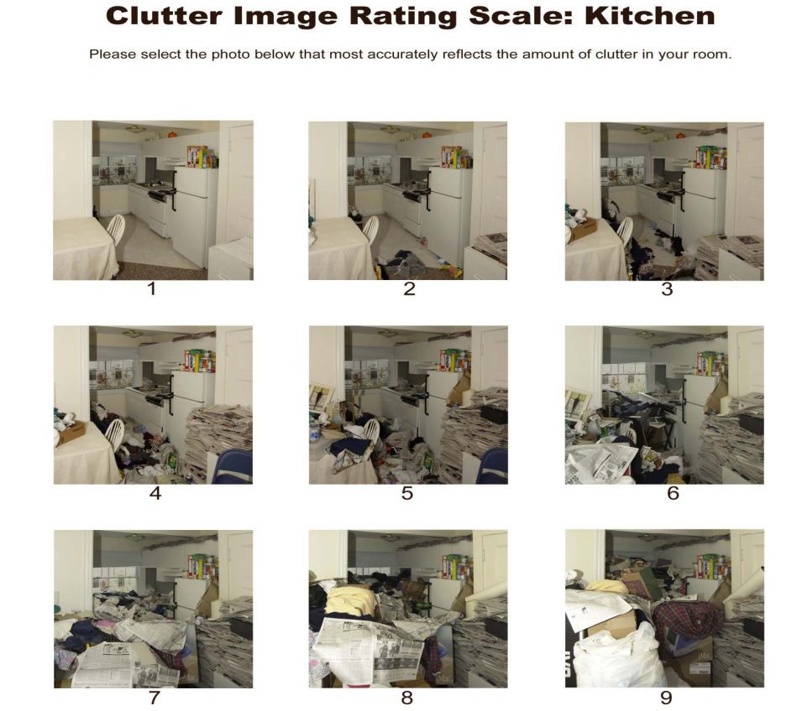

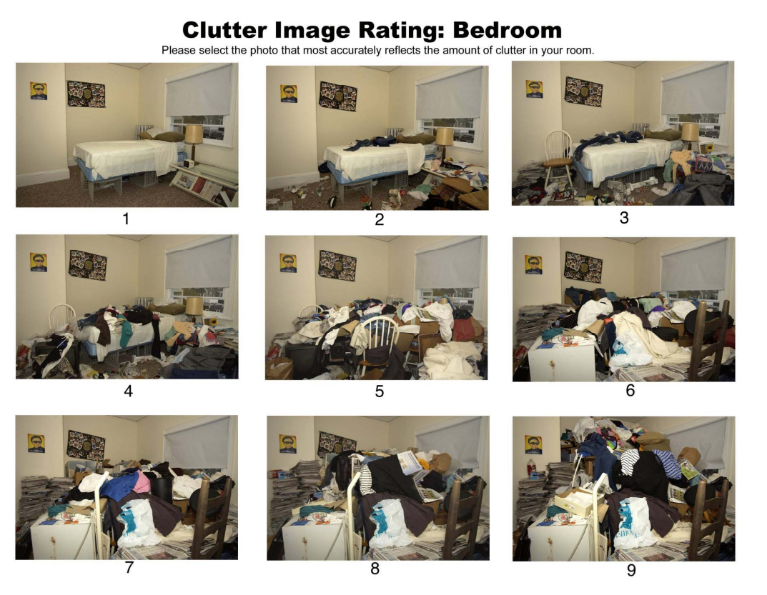

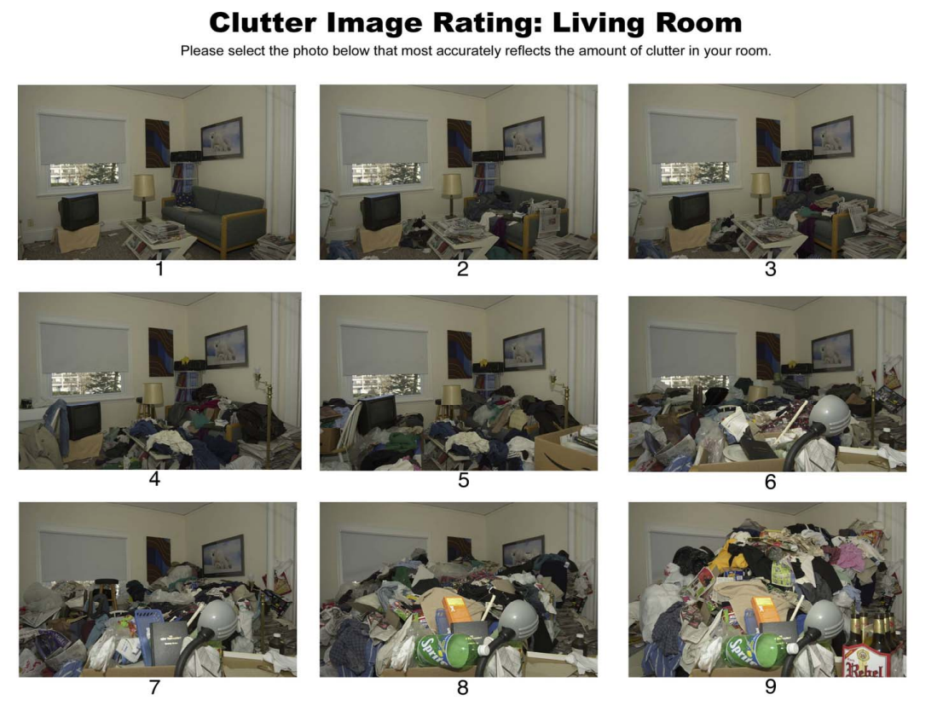
Clutter rating illustrations with thanks to Clutter Image Ratings - Hoarding Disorders UK

Guidance developed with information from:
- working_with_people_who_self-neglect_pt_web.pdf (researchinpractice.org.uk)
- WM_Self-neglect_guidance_v30.pdf (safeguardingwarwickshire.co.uk)
- self-neglect_policy_and_guidance_.pdf (safeguarding-bathnes.org.uk)
WSAB and HSAB believe that all information from published and unpublished sources has been referenced. Any queries or concerns should be raised with the WSAB or HSAB Manager.

Care and support statutory guidance - GOV.UK (www.gov.uk)
Braye S, Preston-Shoot M (2020) Working with people who self-neglect: Practice Tool, Research in Practice
Analysis of Safeguarding Adult Reviews: April 2017 - March 2019
Hoarding disorder - NHS (www.nhs.uk)
Martineau, S. J., Cornes, M., Manthorpe, J., Ornelas, B., & Fuller, J. (2019). Safeguarding, homelessness and rough sleeping: An analysis of Safeguarding Adults Reviews. NIHR Policy Research Unit in Health and Social Care Workforce, The Policy Institute, King's College London. https://doi.org/10.18742/pub01-006
Care Act 2014 (legislation.gov.uk)
Care and support statutory guidance - GOV.UK (www.gov.uk)
Care and support statutory guidance - GOV.UK (www.gov.uk)
Revisiting safeguarding practice (publishing.service.gov.uk)
Mental Capacity Act 2005 (legislation.gov.uk)
The Human Rights Act | Equality and Human Rights Commission (equalityhumanrights.com)
European Convention on Human Rights (coe.int)
Braye S, Preston-Shoot M (2020) Working with people who self-neglect: Practice Tool, Research in Practice
Strengths-based approach: Practice Framework and Practice Handbook (publishing.service.gov.uk)
Making Safeguarding Personal toolkit | Local Government Association
Fitzpatrick, S. and Johnsen, S. and White, M. 2011 ‘Multiple Exclusion Homelessness in the UK: Key Patterns and Intersections’; Social Policy and Society; 10: 501 – 512
St Mungos 2018 ‘Dying on the Streets’ Dying-on-the-Streets-Report.pdf (mungos.org)
SCIE. Report 69 (Braye et al, 2014) ADD
Mental-Capacity-Guidance-Note-Capacity-Assessment-January-2022.pdf (netdna-ssl.com)
Braye S, Orr D and Preston-Shoot M (2015) Practice tool: Working with people who self-neglect. Dartington; Research in Practice for Adults
Lee, S; Fenge, L; Brown, K and Lyne, M (Eds) ‘DE-Mystifying Mental Capacity’ 2021
ADASS 2020 ‘Adult Safeguarding and Homelessness: a briefing on positive practice’ online at Adult safeguarding and homelessness: a briefing on positive practice | Local Government Association

