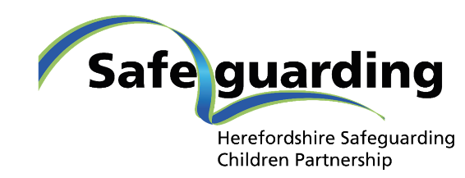
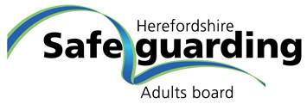
Whistleblowing – Speaking Up About Wrong Doing
If you See Something, Say Something

It is important that all staff members and volunteers are vigilant in order to keep children as well as adults who access support safe. We must be alert to the potential for abuse and neglect and speak up.
In addition to this document you may need to refer to:
- Your organisations Whistleblowing Policy
- Your organisations Safeguarding Children and Safeguarding Adults Policies
- Herefordshire Safeguarding Policies
- Professional Codes of Conduct

What Is A Whistleblower?
You’re a whistleblower if:
- You are a worker and you report certain types of wrongdoing. This will usually be something you’ve seen at work - though not always.
- The wrongdoing you disclose must be in the public interest. This means it must affect others, for example the general public (GOV.UK, 2020).

Who Is Protected By Law?
You’re protected if you’re a worker, for example you are:
- an employee, such as a police officer, NHS employee, office worker, factory worker
- a trainee, such as a student nurse
- an agency worker
- a member of a Limited Liability Partnership (LLP) (GOV.UK, 2020)

Why Might I Need To Speak Up?
- Concerns about serious injury or death
- Because it is in the public interest (a concern has an impact on more than one individual's employment contract)
- To address bullying, abuse or neglect
- Deal with abuse of power, position or authority
- Highlight a failure to treat people with dignity

Can I Speak Up If It Is Something That Happened In The Past Or ‘Might’ Happen Now?

You can raise your concern at any time about an incident that happened in the past, is happening now or you believe will happen in the near future.

Complaints That Count As Whistleblowing:
You’re protected by law if you report the following (you must reasonably believe that your concern fits here):
- a criminal offence, such as fraud
- someone’s health and safety is in danger
- risk or actual damage to the environment
- a miscarriage of justice
- a company is breaking the law, for example does not have the right insurance
- you believe someone is covering up wrongdoing (GOV.UK, 2020)

Complaints That Do Not Count As Whistleblowing:

Personal grievances (for example bullying, harassment, discrimination) are not covered by whistleblowing law, unless your particular case is in the public interest. Instead these matters should be reported under your
employer’s grievance policy.
Contact the Advisory, Conciliation and Arbitration Service (Acas) for help and advice on resolving a workplace dispute
(GOV.UK, 2020)

Who To Tell And What To Expect
You can tell your employer – refer to your whistleblowing policy, this will tell you how to report and what will happen next, including how you will be supported.
If you feel unable to report your concern to your employer, or you have and they have not acted on it, refer to your policy to see who else you could speak to within your organisation, alternatively, you can phone Protect, Speak Up or the NSPCC (see section below), get legal advice from a lawyer, or tell a prescribed person or body about your concerns (Click here for a list of Prescribed Persons or Bodies relevant to adult and children’s social care, health and Charities, such as Ofsted or the Care Quality Commission (GOV.UK, 2020).
In the NHS you can speak to your Freedom to Speak up Guardian or Champion.

Where Can I Get Support To Decide How To Raise My Concern?
Refer to organisational policy, contact the organisations below if are unsure how to raise your concern:
Speak Up - Independent, confidential advice on the speaking up process NHS and social care sector. Website here Employees on-line Decision Making Tool here or call 08000 724 725.
Protect – Making whistleblowing work for individuals, organisations and society. Website here or call for confidential whistleblowing advice. 020 3117 2520
NSPCC - Advice and support to professionals with concerns about how child protection issues are being handled in their own or another organisation. Website here Call 0800 028 0285 or email help@nspcc.org.uk

Resources:

Raising Concerns film here
- Responding to Concerns film here
- Case Studies from Protect here
- Training materials from Speak Up here

References:
With thanks to Shropshire Safeguarding Community Partnership for the use of their template
Version 2 August 2022
- GOV.UK (2020) Whistleblowing for employees: GOV.UK. https://www.gov.uk/whistleblowing
- The Children’s Commissioner’s Office (2020) Whistleblowing to the Children’s Commissioner about the rights, welfare and interests of children in England Policy and guidance for whistleblowers. January 2020. London: The Children’s Commissioner’s Office. https://www.childrenscommissioner.gov.uk/report/whistleblowing
-report/

