# Quick Guide for Practitioners: Child Neglect

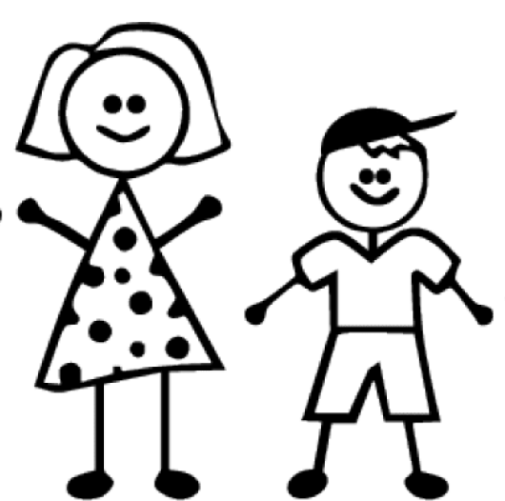

EFFECTS OF NEGLECT

* Neglect can lead to poor health, education and social outcomes, and is potentially fatal.
* Children’s abilities to attend and achieve at school is reduced.
* Children’s emotional health and well-being is often compromised and this may impact on their success in adulthood, their ability to form good relationships and to parent in the future.

WHAT DOES RESEARCH TELL US?

Research tells us that children neglected in very early childhood can have the biology of their brain development affected. This results in:

* Difficulty regulating emotions,
* Reduction of cause and effect thinking,
* Difficulty in recognising emotions in others or an ability to articulate their own emotions, and
* after 2 years of age these deficits may be difficult to overcome.

Children of any age can be affected, including adolescents (11-18 years), whose brains are also rapidly developing.

KEY MESSAGE

Neglect is **preventable** and can be tackled if agencies **work together** to develop the range of responses required for intervening at a number of levels. Many professionals are in a position to **identify the early signs** of child neglect. Your **professional curiosity** and the **Voice of the Child** is key as it is the collation and analysis of sometimes small and seemingly insignificant events that only when viewed together provide evidence that neglect is an issue of concern.

DEFINITION OF CHILD NEGLECT

Child neglect is the persistent failure to meet a child’s basic physical and/or psychological needs, likely to result in the serious impairment of the child’s health or development. Neglect may occur during pregnancy as a result of maternal substance abuse. Once a child is born, neglect may involve a parent or carer failing to:

* Provide adequate food, clothing and shelter (including exclusion from home or abandonment);
* Protect a child from physical and emotional harm or danger;
* Ensure adequate supervision (including the use of inadequate care-givers); or
* Ensure access to appropriate medical care or treatment. It may also include neglect of, or unresponsiveness to, a child’s basic emotional needs.’ (Working Together 2018)

Neglect usually happens over a period of time although sometimes it is a one-off event. There are different types of neglect, including physical (including nutritional and protection from online harm), medical, emotional (including social and identity neglect) and educational. A child who is neglected will often suffer from other abuse as well, both inside and outside of the home.

**It is the cumulative effect of neglect which has the most impact.**

WHAT CAN PROFESSIONALS AND OTHERS DO?

**Child neglect:**

Be aware of the warning signs and symptoms of child neglect, which vary from child to child. The child:

* May seem like they haven’t washed, are dirty/smelly, or their clothes seem dirty.
* May be hungry or asking for other people’s food.
* May often come to school with no lunch money or packed lunch.
* May often not turn up for school, or they arrive late.
* May not seem to have many friends.
* May get sent to school even when they are really unwell.
* May have an unusual relationship with a parent e.g. parents show a lack of compassion, or the child may seem anxious not to upset the parent and even appear to be afraid of them.
* May not be growing and developing as they should.
* May appear to be nervous, unusually fussy or very withdrawn.
* May copy or act out what they have experienced at home, such as violence or sexual behaviour.
* May have unexplained injuries.
* May not receive health care when they need it.
* Parents don’t seem to know where they are or what they are doing.

By understanding these indicators, problems can be addressed as early as possible and the right support and services for the child and their family provided.

**Adolescent neglect:**

Whilst neglect is usually an act of omission, be aware that adolescent neglect can be:

* A deliberate act where young people may be abandoned by parents or forced to leave home.
* Parents not being aware of their child’s activities outside the home, including online.
* Parents not making sure they get health care when they need it.
* Parents not taking an interest in their education.
* Parents failing to provide emotional support with problems or offering encouragement.



**Skills and Knowledge – Practitioners can:**

* Attend Child Neglect and Graded Care Profile 2 (GCP2) training and other courses offered by your own organisation. See [**www.herefordshirecpd.co.uk**](http://www.herefordshirecpd.co.uk)
* Take responsibility for knowing where you can access information/toolkits/guides on how to identify child neglect and what subsequent actions you should take within your own organisation. See the [**HSCP Child Neglect Resources**](https://www.herefordshiresafeguardingboards.org.uk/child-neglect-practitioner-resources) page.
* Keep your continuous professional development (CPD) up to date with current research and the learning from Local Child Safeguarding Practice Reviews.

FIND OUT MORE ABOUT CHILD NEGLECT

* [**HSCP Child Neglect Resources**](https://www.herefordshiresafeguardingboards.org.uk/child-neglect-practitioner-resources)
* [**Troubled Teens: a study of the links between parenting and adolescent neglect**](https://www.childrenssociety.org.uk/information/professionals/resources/troubled-teens-links-between-parenting-and-adolescent-neglect)
* **[Ofsted report: In the child’s time: professional responses to neglect](https://assets.publishing.service.gov.uk/government/uploads/system/uploads/attachment_data/file/419072/In_the_child_s_time-professional_responses_to_neglect.pdf)**
* [**Neglect: learning from case reviews | NSPCC Learning**](https://learning.nspcc.org.uk/research-resources/learning-from-case-reviews/neglect)
* **NSPCC resources on child neglect:** **[Neglect is also Child Abuse: Know All About It | NSPCC](https://www.nspcc.org.uk/what-is-child-abuse/types-of-abuse/neglect/)**
* **Free multi-agency training –** [**www.herefordshirecpd.co.uk**](http://www.herefordshirecpd.co.uk)

GRADED CARE PROFILE 2

The Graded Care Profile 2 (GCP2) is an evidence-based assessment tool that helps professionals measure the quality of care provided by a parent or carer in meeting their child's needs, particularly where there are concerns about neglect.

**What is a GCP2 assessment?**

The GCP2 is a widely used assessment tool designed to help identify when a child is at risk of neglect. The GPC2 measures the quality of care given to an individual child over a short window of time (i.e. it represents the current level of care). The tool is completed with the family, to help identify areas where the child may need additional support, or where the level of care needs to improve.

The areas of care are based on Maslow’s Hierarchy of Needs (physical care, care of safety, emotional care (love and belonging), and developmental care (care of esteem) which are then further subdivided.

Practitioners need to complete GCP2 training to be licensed to use the tool.

**Link to book on GCP2 training:** [**www.herefordshirecpd.co.uk**](http://www.herefordshirecpd.co.uk)

RESOURCES AND TOOLS FOR PRACTITIONERS

The Herefordshire Safeguarding Children Partnership has developed some tools and resources to support practitioners to identify and respond to child neglect. This includes the:

* Child Neglect Screening Tool
* A Day in My Life Guide and Templates
* Multi-agency chronology tool

These tools can be found on the [**Child Neglect Resources page**](https://www.herefordshiresafeguardingboards.org.uk/child-neglect-practitioner-resources) of the HSCP website.