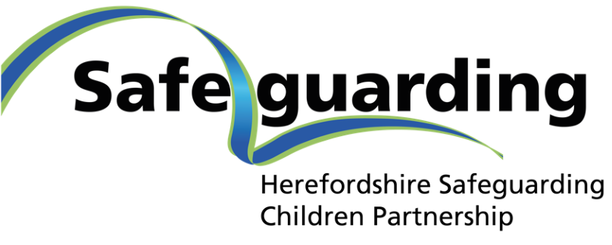

Multiagency Safeguarding Arrangements (MASA)

Published: Sept 2019
Updated: November 2023
Review Date: December 2024
Foreword
West Mercia Police (Chief Constable), Herefordshire and Worcestershire Integrated Care Board (Accountable Officer) and Herefordshire Council (Chief Executive), are the Safeguarding Children Partners for Herefordshire, as defined by the Children and Social Work Act 2017. We are very pleased to present our revised local multi-agency arrangements to safeguard children. They replace the previous arrangements published in September 2019 to deliver the requirements of the Government’s statutory guidance Working Together to Safeguard Children, 2018; and set out our local commitment to the children of Herefordshire.
We wish to acknowledge the dedication and hard work of all those involved in keeping children safe in Herefordshire and who have contributed to this revision through a range of engagement activities and consultations. The new arrangements will continue to directly involve everyone who has a responsibility to keep children safe and well in the county.
Herefordshire safeguarding arrangements depend on the full engagement and cooperation across early year’s settings, schools, colleges, health services, GPs, police, voluntary and community groups, private providers and other services such as housing, the fire service, youth justice, probation, and with children and families themselves.
We set out here how we will organise our strategic safeguarding arrangements, and how we, the lead statutory safeguarding partners – the Council, the Integrated Care Board and the Police, will work in partnership with other agencies to identify and respond to the needs of children and young people in Herefordshire.
We remain positive about these revised arrangements and we continue to be ambitious to ensure the best outcome for the children and young people of Herefordshire through our ‘Right Help Right Time’ approach to identifying and responding to need. We also recognise that more needs to be done to improve effectiveness, such as how we listen and act on the voices of children and young people and learn from serious incidents. We will hold each other to account, learn from experience when things do not go as well as they should, and we will celebrate best practice together. We see this, as a real opportunity to make improvements, to innovate and to tackle those things children and young people need us to tackle and to keep them safe and well.
Paul Walker  Chief Executive  Herefordshire Council | Alex Murray  Temporary Chief Constable Police  West Mercia Police | Simon Trickett  Chief Executive  Herefordshire and Worcestershire Integrated Care Board

Contents
1. Introduction 5
2. Statement of Purpose 6
3. Vision, Values and Principles 7
4. Geographical Area and Local Context 9
5. Arrangements for the safeguarding partners to work together to identify and respond to the needs of children in the area 10
6. Relevant Agencies and Strategic Partnerships 11
7. Leadership and Governance 15
Joint Case Review Subgroup 19
8. Quorum for the HSCP Board and Subgroups 21
9. The HSCP Partnership Team 21
10. Priority Themes 21
11. How the arrangements will include the voice of children and families 22
12. How all early years settings, schools (including independent schools, academies and free schools) and other educational establishments will be included in the safeguarding arrangements 23
13. How any youth custody and residential homes for children will be included in the safeguarding arrangements 24
14. How the safeguarding partners will use data and intelligence to assess the effectiveness of the help being provided to children and families, including early help 25
15. How the Right Help Right Time - Threshold Guidance setting out the local criteria for action, aligns with the HSCP multiagency safeguarding arrangements 25
16. Arrangements for commissioning and publishing local child safeguarding practice reviews 26
17. The process for undertaking local child safeguarding practice reviews, setting out the arrangements for embedding learning across organisations and agencies 27
18. Child Death Reviews 28
19. How inter-agency learning and development offer will be commissioned, delivered and monitored for impact and how they will undertake any multiagency and interagency audits 29
20. Audits 30
21. Arrangements for independent scrutiny of the effectiveness of the arrangements, how the arrangements are reviewed; how any recommendations are taken forward, and independent scrutiny of the report Safeguarding Partners must publish at least once a year 30
22. Annual Report 31
23. Funding and Business Support and Partnership Team 32
24. Annual Business cycle 33
25. Multi-agency Procedures 33
26. Communications 33
27. Dispute Resolution 34
28. Risk Assessment 34
29. Amendments to Herefordshire’s MASA 34
Appendix 1 – schools and education providers in Herefordshire regarded as relevant agencies for local safeguarding arrangements 35
Appendix 2 – Early Years providers in Herefordshire regarded as relevant agencies for local safeguarding arrangements – funded providers other than sole traders. 36
Appendix 3 - HSCP Structure 37

Introduction
  - In September 2019, Herefordshire introduced local Multi-Agency Safeguarding Children Arrangements to reflect the fundamental legislative changes to the Children Act 2004, which was amended by the Children & Social Work Act 2017.

  - The Act meant that Local Safeguarding Children Boards were no longer required and were replaced by more flexible arrangements determined locally. The Herefordshire Safeguarding Children Partnership (HSCP) arrangements reflect the fundamental legislative changes to the Children Act 2004, which was amended by the Children & Social Work Act 2017. Working Together to Safeguard Children: A guide to inter-agency working to safeguard and promote the welfare of children (WT2018), is the statutory guidance for the Children and Social Work Act 2017.

  - The Act requires the three safeguarding partners – Local Authority, Integrated Care Board, and Police – to publish local safeguarding children arrangements and to take equal responsibility for the co-ordination and effectiveness of those arrangements.

  - During 2020 we reviewed our arrangements through a range of engagement activities and consultations. We are pleased to present the revised version of these arrangements as we move through 2023.

  - The three local safeguarding partners who are accountable and have joint and equal responsibility for the multiagency safeguarding arrangements are:

  - Paul Walker, Chief Executive, Herefordshire Council
  - Alex Murray, Temporary Chief Constable Police West Mercia Police
  - Simon Trickett, Accountable Officer Herefordshire and Worcestershire Integrated Care Board

  - The three safeguarding partner officers that have been given delegated authority to jointly lead the partnership are:
Herefordshire Council: Represented by Darryl Freeman  the Director of Children’s Services and their Service Director – Victoria Gibbs | The Herefordshire and Worcestershire Integrated Care Board: Represented by Kath Cobain the Chief Nursing Officer and the Head of Safeguarding & Designated Nurse for Safeguarding Adults and Children – Heather Manning | West Mercia Police: Represented by Helen Wain  the Superintendent Policing Commander for Herefordshire Local Policing Area and the Detective Chief Inspector for the local policing area – Ross Jones

  - To fulfil the above role the safeguarding partners have set out how they will work together and engage with any relevant agencies to safeguard and protect the welfare of children in the area.

  - The three Safeguarding Partner organisations have a shared and equal duty to make arrangements to work together with relevant agencies to safeguard and promote the welfare of all children in Herefordshire.

  - In Herefordshire, we have a highly engaged group of relevant agencies who care passionately about meeting the needs of our county’s children and young people. We know that safeguarding is everybody’s responsibility and together with the partnership, through our new arrangements we have a genuine ambition to ensure that everyone, including early years settings, schools, colleges, health commissioners and providers, police, voluntary and community organisations, housing providers, youth justice and all those services who have a role in safeguarding children and young people, will know, understand and respond to those responsibilities in a way that has a really positive impact on the children and young people we serve.

  - Partners in Herefordshire recognise that arrangements must be purpose-driven and therefore agile and adaptive to the local community and the organisational environment, and also to national priorities and policy developments. Furthermore, our local arrangements need to learn from experience, and develop towards greater effectiveness on the basis of that learning. We expect therefore that our local safeguarding arrangements will evolve over time, whilst remaining compliant with statutory duties; this document will be updated as required in order to reflect developments.

  - The local arrangements follow the format of Working Together 2018 (WT2018) chapter 3: paragraphs 38 and 39, with additional sections of WT2018 referenced in brackets.

Statement of Purpose
  - The Safeguarding Partners are required to:

- agree the coordination of safeguarding services – how we will work together and with other relevant agencies (relevant agencies are those whose involvement may be required to safeguard and promote the welfare of children’s needs -locally)
- act as a strategic leadership group in supporting and engaging others
- implement local and national learning including from serious child safeguarding incidents

  - The statutory safeguarding partners are responsible for coordinating and ensuring the effectiveness of work undertaken by local agencies to safeguard and promote the welfare of children, but it is not accountable for their operational work and individual agencies/organisations each retain their own existing lines of accountability for their services.

  - The HSCP does not have the power to direct other organisations, however it will bring concerns to the attention of the agency concerned and the partnership where required.

  - The purpose of the children’s multiagency safeguarding arrangement (MASA) is to support and enable local organisations in a system that ensures:
- children are safeguarded, and their welfare promoted
- partner organisations and agencies collaborate, share and co-own the vision for how to achieve improved outcomes for vulnerable children
- organisations and agencies challenge appropriately and hold one another to account effectively
- there is early identification and analysis of new safeguarding issues and emerging issues
- learning is promoted and embedded in a way that local services for children and families can become more reflective and implement changes to practice
- information is shared effectively to facilitate more accurate and timely decision making for children and families
- Local data from all agencies is developed strategically and is used to identify and respond to vulnerability and risk to further help and protect children.

  - Primarily, the responsibilities of the partnership are to promote high standards of safeguarding work and to foster a culture of continuous learning and improvement. Through its work the partnership it will identify and act on identified weaknesses in services and measure how improvements are having an impact on children & families.
  - The responsibilities of the HSCP is to drive, coordinate, develop, challenge, and monitor the delivery of effective safeguarding practice by all agencies across Herefordshire.
  - The HSCP will provide the overall strategic direction for the development of safeguarding services for children and young people and will fulfil the statutory functions required in the new legislation, with a clear focus on quality and learning.
  - This includes agreeing ways to co-ordinate safeguarding services, providing strategic leadership in supporting and engaging others, and implementation of local and national learning from serious child safeguarding incidents.
  - Through the development, implementation and review of the annual business plan, the HSCP will determine and review annual priorities.
  - They will ensure that the arrangements across the partnership have a clear focus on hearing the voices of children & young people and how these are being acted upon.
  - The partners will produce an annual report which will be published on the safeguarding website.

  - The HSCP will receive assurance of the effectiveness of arrangements through:

- Bi-annual assurance from Relevant Agencies s11 or (education only S175 Audit) in accordance with the West Midlands Regional SCP arrangements;
- quarterly performance data, single agency audit findings;
- single agency evidence of impact of improvements made following learning reviews;
- completed activity from the performance framework;
- findings from the Scrutineer’s quarterly activity: such as reflections on strengths and areas of development, walk the floor activity and evaluation of audit findings.
- In addition, feedback from children, young people and their families will be central to our work and shaping future priorities
- Multi agency and single agency audit outcomes

Vision, Values and Principles
  - The values and principle for all children and young people in Herefordshire is to grow up with their needs met well, that they are safe from harm and that our multi agency arrangements designed to support this will be of the highest quality with children at the heart of all we do.

  - Our Vision
‘Children are safely cared for by their family because services work well together, and with families’

  - Our values and principles have been developed in collaboration with children, young people and partners, through a variety of engagement activities.

The HSCP Values

- Child Focussed
- Collaboration
- Transparency
- Inclusivity

  - The HSCP Principles

- Children are at the heart of what we do and we will learn from the actions we take
- We will make a difference to the lives of children and young people
- We will focus on the difference our partnership makes to the lives of children and young people
- We will share information and work together with openness, respect, trust and confidence
- We will challenge each other when this is needed and will welcome challenge in return, knowing that this helps to keep our children and systems safe
- We will address the well-being needs of children and young people at the earliest opportunity and prevent the need for later child protection intervention whenever possible – providing the ‘Right Help at the Right Time’

  - The HSCP Pledge

- Our role is to keep children safe and give them a voice
- Our commitment is to make sure everything we do works for children
- We will make sure that children are at the heart of what we do

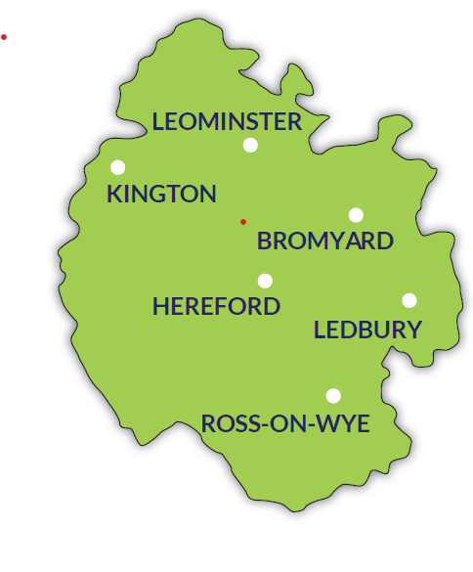
Geographical Area and Local Context
  - Herefordshire is a predominantly rural county, with the 4th lowest population density in England (0.87 persons per hectare). The vast majority (95 per cent) of the county’s land area is classified as rural according to Defra’s 2011 rural/urban definition.

4.2 It is situated in the south-west of the West Midlands region bordering Wales. The city of Hereford, in the middle of the county, is the centre for most facilities; other principal locations are the five market towns of Leominster, Ross-on- Wye, Ledbury, Bromyard and Kington.

Figure 1
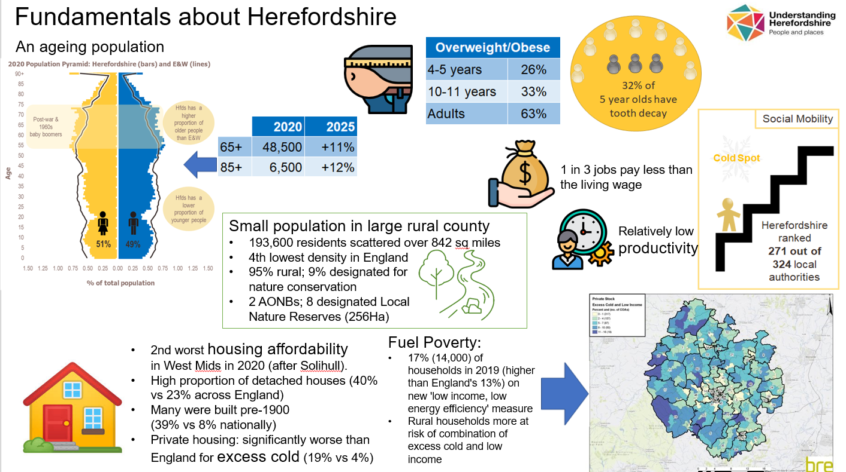
Understanding Herefordshire, JNSA 2021 data

Arrangements for the safeguarding partners to work together to identify and respond to the needs of children in the area
  - The revised partnership arrangement will be discharged through the HSCP, the structure is set out in appendix 3.

  - The lead Safeguarding Partners meets quarterly to provide overall strategic leadership and direction to the arrangements. Throughout the development of these new arrangements, they have emphasised that the new shared lead responsibilities will in no way diminish the importance of the responsibilities and contributions of all the other relevant agencies in Herefordshire who play such a vital role in safeguarding children and young people. We are responsible collectively as a partnership for strategic co-ordination and delivery of safeguarding services for children and young people across Herefordshire.

  - Following the review of the arrangements set out in September 2019, it was recognised that there was a need to strengthen and revise governance arrangements, the structure and number of sub-groups across the HSCP (appendix 3)

  - Sub-groups are chaired by the Safeguarding Partners or delegated senior officers in their agency. Other groups may be chaired by appropriate senior officers from relevant agencies.

  - Further members of the Safeguarding Children Partnership may be co-opted, invited to attend HSCP meetings to present items in relation to specific issues or where there is agreed joint strategic priorities, co-production and work to address cross cutting themes from other partnerships.

  - Relevant agencies continue to support and be engaged with the Partnership, through the delivery of priority work streams through the subgroups, as well as task and finish groups or other specific projects, such as developing learning webinars or presenting/facilitating at the Practitioner Forum.

  - The Safeguarding Partners hold twice yearly Summits, the purpose of which are to update the executive leads of Relevant Agencies of the work Partnership and its effectiveness; as well as to highlight any gaps and where further support and engagement is required.

Delegated Authority
  - As set out in Working Together 2018, the lead representatives are able to delegate their functions although they retain accountability for any actions or decisions taken on behalf of their agency. In Herefordshire, the respective agencies have identified the following Senior Officers who have been given delegated authority to ensure continuity and full participation with the MASA in the event of lead representative absence.

  - The Senior Officers have delegated authority to speak on behalf of the Safeguarding Partner they represent, make decisions on behalf of their organisation or agency and commit them on policy, resourcing and practice matters, and hold their own organisation or agency to account on how effectively they participate in and implement the local MASA.

  - Partnership meetings include the attendance of the safeguarding partners delegated authority namely:

- Herefordshire Council: Represented by the Director of Children Services and their Service Director.
- West Mercia Police: Represented by the Superintendent Policing Commander for Herefordshire Local Policing Area and the Detective Chief Inspector for the local policing area.
- The Herefordshire and Worcestershire Integrated Care Board: Represented by the Chief Nursing Officer and the Head of Safeguarding & Designated Nurse for Safeguarding Adults and Children.

  - For 2023 – 24, Safeguarding Partners have agreed that the Safeguarding Partnership Board is chaired by the Independent Scrutineer to support independent scrutiny and oversight of the partnership and to allow Safeguarding Partners to devote their focus on the demands of implementing the Children’s Improvement Plan overseen by the Children Improvement Board. The decision making function is held by the three safeguarding partners.

  - To further this ambition, the Safeguarding Partnership will develop close structural relationships with the Health and Well-being Board, Safeguarding Adults Board and Community Safety Partnership, as illustrated in the governance structure appendix 3.

Relevant Agencies and Strategic Partnerships
  - The strength of local partnership arrangements working relies on the safeguarding partners working collaboratively with relevant agencies. The role of relevant agencies is not underestimated and is required to help safeguard and promote the welfare of children and the partnership will engage with relevant agencies to enable joint identification response to exiting and emergent need and to agree priorities to improve outcomes for children.

  - In Herefordshire services with the statutory safeguarding partner agencies and our Relevant Agencies are set out below:

Statutory Safeguarding Partners

- West Mercia Police
  - Other police departments
- Herefordshire Council as corporate parents
  - Children’s Services
  - Other council departments
- Herefordshire and Worcestershire Integrated Care Board (HWICB)

The Safeguarding Partners respective scrutiny and accountability arrangements are as follows:
- Herefordshire Council Scrutiny Board
- ICB Governing Body
- Office of Police and Crime Commission

Each Safeguarding Partner is responsible, (through its own organisations governance arrangements) for reporting back to its governing body on updates relating to the delivery of the multiagency safeguarding arrangements and any emerging issues.

Relevant Agencies

  - Working Together to Safeguard Children 2018 defines relevant partners as those organisations and agencies whose involvement the safeguarding partners consider may be required to safeguard and promote the welfare of children with regard to local need.

  - These partners will include, but is not limited to:
Health Providers
- General Practitioners and primary care professionals
- Wye Valley NHS Trust
- UK Health Security Agency and the Office for Health Improvement and Disparities (OHID),
- West Midlands Ambulance NHS Trust
- NHS England
- Herefordshire and Worcestershire Health and Care NHS Trust (HWHCT)
- Substance Misuse Services,
- Sexual health services

Education
- All Early Years and Children Centre providers
- All Primary Schools, Secondary Schools, Special Schools
- Further Education & Colleges including post 16 settings and training providers
- Pupil referral units

Other agencies
- Herefordshire Voluntary Support Organisation Services (HVOSS)
- Faith organisations
- Domestic Abuse Services
- Herefordshire and Worcestershire Youth Offending Service
- Herefordshire and Worcestershire Fire and Rescue Service
- Housing Providers
- British Transport Police
- National Probation Service
- CAFCASS
- Local Providers of Children’s Residential Units
- Border Force and Immigration Services

Close links with other Strategic Partnerships and Groups
  - There are clear benefits to children young people, families and vulnerable adults coordinating specific areas of business cross partnership. The HSCP does not operate in isolation, and there are a range of other multi agency partnership arrangements which contribute significantly to the children’s and adults safeguarding agenda and their respective priorities in order to influence the effective development and commissioning of services for the benefit of children, young people families and vulnerable adults. This includes the following partnership arrangements:

  - Corporate Parenting Board - The Council has Corporate Parenting responsibility for Children Looked After (CLA) and Care Leavers up to the age of 25. The council endeavours to treat CLA and Care Leavers as “their own” children.

  - The Corporate Parenting Board (CPB) acts to assist the Council in continuing to fulfil its legal obligations and responsibilities towards CLA and leaving care under the Children Act 1989, Children Leaving Care Act 2000, Children and Families Act 2014 and all associated legislation, regulations and statutory guidance pertaining to CLA and Care Leavers within England.

  - Herefordshire Children & Young People’s Partnership (CYPP) – This partnership is responsible for the development and implementation of Herefordshire’s Children & Young People’s Plan. This plan aims to make sure that children and young people in the county are given the best possible start in start in life so that they grow up healthy, happy and safe within supportive family environments. The plan provides a framework that all members of the Herefordshire Children and Young People’s Partnership can use to address the strategic needs of children, young people and their families in Herefordshire.

  - Children Improvement Board – Following a High Court Judgement in March 2021, and Ofsted inspection finding the local authority inadequate in September 2022, a Children’s Services Improvement Board was formed, chaired by Gladys Rhodes White, DFE Improvement Advisor, to oversee the improvement journey, consisting of representatives from a wide range of agencies who work with children and young people.

  - Health and Well-being Board - The Health and Wellbeing Board (HWBB) is made up of members that represent the organisations responsible for improving health and wellbeing in Herefordshire. The health and wellbeing strategy sets out how the council and its local partners plan to address the health and wellbeing needs of its population and as such, is a key document that is jointly owned and one that promotes collective action to meet those needs.

  - SEND Strategic Board - The SEND Strategic Assurance Board meets regularly to oversee what is happening across the area. They make regular checks on what is working and what needs improvement for children with Special Educational Needs and Disability across Herefordshire. The SEND Strategic Assurance Board is chaired by an independent advisor and its membership includes senior leaders from health and Herefordshire local authority, school, college and early years professionals, families and young people and community support.

  - Herefordshire Community Safety Partnership (CSP) – The overall aim of this partnership is to help improve the safety and well-being of residents and visitors to the county. The Partnership work includes working to bring offenders to account and cut levels of reoffending, addressing the harm caused by domestic violence and abuse, minimising the impact of alcohol and drugs on our communities and promoting community togetherness and cut antisocial behaviour. The work of the current Child Exploitation group is now included in the HSCP arrangements to ensure oversight and governance by the Safeguarding Partners. This partnership along with the HSCP are working together to target crime which impacts on the safety and welfare of children and young people.

  - Herefordshire Safeguarding Adults Board (HSAB) - This board brings together representatives from various agencies and organisations in Herefordshire to work in partnership to protect adults in Herefordshire. By sharing best practice and expertise the board works to ensure that adults have access to the right support and services they need. The Joint Case review group which is currently in place operating as a learning sub group to both the children and adults safeguarding board/partnership, and the Community Safety Partnership, will continue in the new arrangements.

  - Serious and Organised Crime Joint Action Group (SOCJAG) – This group is one of four in the West Mercia area, and was established to ensure more effective partnership working arrangements to tackle serious and organised crime.

  - Multi Agency Risk Assessment Conference (MARAC) – is a meeting that is held to discuss the most high risk cases of domestic abuse and sexual violence, to share information and to safety plan to safeguard a survivors of abuse. MARAC works closely with the partnership, the intelligence and information from this group informs the response to domestic violence strategically and operationally.

  - Multi-Agency Public Protection Arrangement (MAPPA) - is the process through which the police, probation and prison services work together with other agencies to assess and manage violent and sexual offenders in order to protect the public from harm.

  - Herefordshire recognised the strong linkages between issues for children and adults and has the intention through a number of the above named strategic partnerships to work in a more integrated ‘whole family’ all-age approach. The safeguarding partnership recognise the key themes that cross cut the different partnership, boards and strategic groups and that all seek to ensure there is coordinated approach particularly in relation to transitional safeguarding, domestic abuse and modern Slavery.

  - It is noted that WT2018 is not prescriptive about the specific meetings and attendees. Herefordshire has developed a structure of meetings and forums that engage all relevant agencies at all levels and in the most appropriate manner.

  - In order to allow the Partnership Board to have a core working membership, and at the same time to engage with a much wider pool of relevant agencies including those in the voluntary and community sector, the children’s Safeguarding Partners, HSAB and HCSP have developed the Safeguarding Children Practitioner Forum, that take place twice a year. This has a mixed agenda of tri-partnership/boards business, presentations, workshops, consultations, etc.

Leadership and Governance
Structure
The diagram below describes the new Herefordshire Safeguarding Children’s Partnership structure.
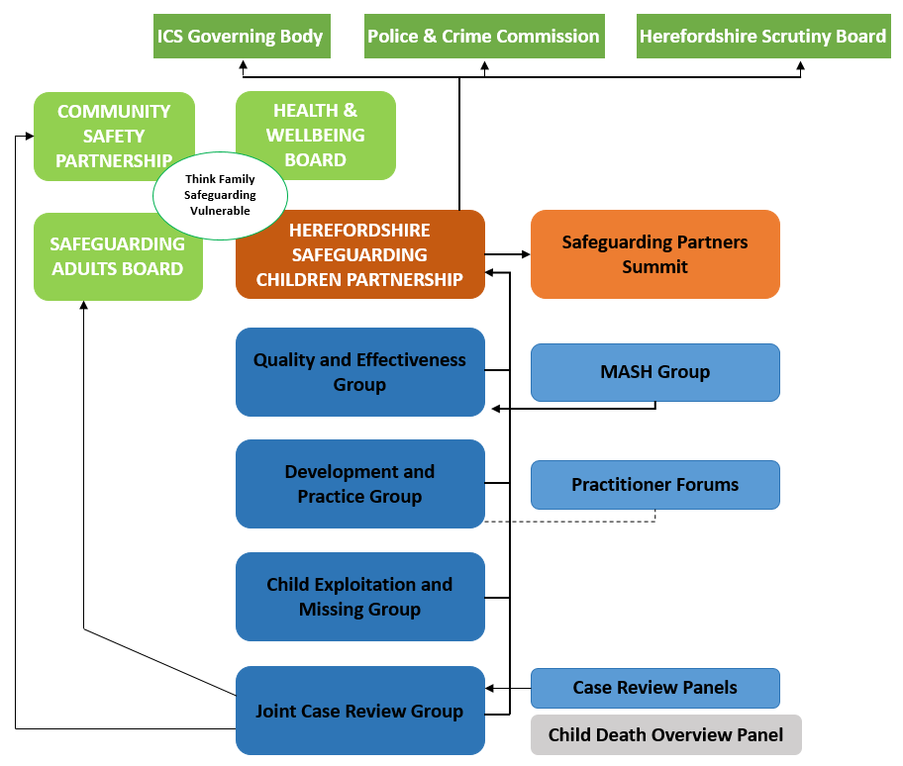
The Herefordshire Safeguarding Children Partnership Board
7.1 The HSCP Board is the overarching local governance of the partnership that will primarily focus on safeguarding systems, performance and resourcing. This group will have the statutory accountability for children’s safeguarding arrangement in Herefordshire. It will:
- Have strategic ownership of the safeguarding arrangements in Herefordshire, with stronger joint responsibility for the whole system
- Drive the work of the partnership, delivering on priorities and ensuring learning from practice and development opportunities have an impact.
- Be responsible for financial, strategic ad reputational risk
- Be responsible for ensuring cross-partnership collaboration and agency participation, convening and supporting participation in the HSCP subgroups
- Have responsibility for ensuring that independent scrutiny of the partnership’s effectiveness is regular and has impact and
- Review progress pf priorities work.
7.2 Part of this group’s agenda will include assurance and challenge sessions where senior officers from partner agencies are invited to provide evidence regarding the effectiveness of their safeguarding arrangements for children and young people within their agency.
7.3 The partners will report to their own internal management, quality and assurance processes to satisfy themselves of their own safeguarding responsibilities, evidence of which will be shared with the HSCP Quality and Effectiveness Group.
7.4 In supporting its working principles, Public Health exists both as a function to assist HSCP and as a commissioning partner with relevant agencies to improve health and wellbeing outcomes for children. A public health approach will promote and encourage the partnership and its relevant agencies to maintain those working principles by remaining outcome focused, maximising prevention, promoting greater integration of services and utilising epidemiological and other forms of intelligence research or evidence to promote planning and decision-making
Membership
7.5 The membership of this group will be the strategic leads: Director of Children Services (DCS) and Service Director, the Superintendent Policing Commander for Herefordshire Local Policing Area and the Detective Chief Inspector for the local policing area, and the Chief Nursing Officer and the Head of Safeguarding & Designated Nurse for Safeguarding Adults and Children. The Partnership Team Manager supports the Board.
Chair
7.6 The Partners have agreed for the Independent Scrutineer to undertake the Chair functions for 2023- 24. The post of the Independent Scrutineer and the Partnership Team for the HSCP will be hosted by the local authority. The Independent Scrutineer/Chair is accountable to the Chief Executive of Herefordshire Council, on behalf of the Safeguarding Partners and has regular meetings to this effect. In order to endure coordination with other partnership arrangements In Herefordshire, there will be at least an annual meeting between the Independent Scrutineer/Chair and all other Herefordshire Boards with a safeguarding remit for vulnerable children and adults that operate across the council.
7.7 In the unlikely event where there is a performance or other issues with the Independent Scrutineer/Chair, the local authority in consultation with the ICB and police will hold him/her to account and address the matter.
Frequency of meetings
7.8 Quarterly with additional meetings to be convened if required.
Core Sub-Groups, Priority Theme Groups and Task and Delivery Groups
  - To complement the high-level strategic nature of the Partnership, HSCP has a two-layered approach to the discharge of its functions with an operational and tactical focus, both of which hold responsibilities and activities from different perspectives and at each level of the partnerships governance. Of importance to the HSCP multiagency arrangements is the arrangements for a partnership summit and frontline practitioner’s forum.

  - The HSCP Summit is held twice a year and is an opportunity for the Safeguarding Partners to stand together and for the success or issues arising from the multiagency safeguarding arrangements.

  - The Summit is open to senior leads of all relevant agencies some of which were former members of the former LSCB. The summit aims
- To provide all strategic leaders and senior managers with opportunity for input, engagement and ownership in the work of the Herefordshire Safeguarding Children Partnership (HSCP)
- To update on the implementation of the HSCP Strategic Plan
- To reflect and input on how to improve effectiveness within the children’s systems and partnership working with children, young people and families
- Provide feedback by Relevant Agencies on their contribution to the safeguarding partnership

  - Practitioner Forum – A joint multi-agency practitioner forum events takes place twice a year, which provide practitioners with a summary of updates arising from work undertaken across Herefordshire relating to the HSCP and HSAB. The forum provides the opportunity to share good practice and update practitioners on developments relating to safeguarding practice. This forum is to engage and hear the views of practitioners and is valued and well attended by practitioners from a range of backgrounds and administrative support from the Partnership Team is provided. All professionals working with adults or children are welcome to attend. These groups are identified in the governance illustration below in appendix 3.

The Delivery Sub-groups

  - The Safeguarding Partnership Board has delegated its functions to a set of standing ‘Delivery Sub-Groups.’ A review of the Board structure saw a new arrangement designed for the subgroups. Primarily to reduce duplication, improve integration and engagement by agencies. The new subgroups forming the partnership is now reduced and will strongly focus on improving practice and ensuring emphasis on learning, enabling a feedback loop across partner agencies and the front line. It has been decided to dissolve the Executive Support Group with the HSCP Board absorbing its functions. The Audit group was also dissolved and its functions assumed by the Quality and Effectiveness group. The Child Neglect Group was absolved, and functions will be delivered by the Development and Practice and Quality and Effectiveness Groups. The MASH Group has been incorporated into one group, which will report to the Quality and Effectiveness Group.

  - The HSCP Partnership Team will support and co-ordinate the work of the subgroups, providing a mechanism for the members to meet regularly outside of normal scheduled meetings, and monitor plans. This will ensure that there is co-ordination and information sharing between sub-groups. Subgroups will report to the HSCP Board. Theses subgroups will be assisted by smaller task and finish groups to develop and deliver specific outcomes. The new subgroup arrangements is now in place.

  - There are currently the following core sub-groups responsible for the delivery of the strategic business plans:

Quality & Effectiveness Sub Group
  - Role: This group is central to changing and improving quality and effectiveness of multi-agency frontline practice. It will scrutinise the work and performance of the safeguarding partner agencies and other relevant agencies in delivering their statutory safeguarding responsibilities and in addressing any local safeguarding priorities identified. It will define operational impact of priorities work and new risks as well as identify the key area of learning for dissemination. There is a need to ask key questions around how we know we are making a difference and to challenge agencies to gather feedback and evidence. The group will use audit, performance data and intelligence to assess the effectiveness of the help being provided to children and families, including early help.

  - The subgroup will produce an annual work plan outlining the multi-agency audit and review activities scheduled for the next 12 months. This group will:
- Collate and analyse relevant performance data to draw out themes and hold partners to account
- Conduct a series of multi-agency audits per year, informed by data intelligence, partnership priorities and findings from case reviews
- Develop and monitor action plans resulting from multi-agency audits or identified performance risks and ensure that actions are completed in a timely way
- Identify whether practice has changed as a result of completed audits and action plans, through performance data review and re-auditing where necessary.
- Ensure that all relevant safeguarding partners are included in multi-agency performance data analysis and audits including schools.
- Review, analyse and challenge relevant single agency audit reports and performance reviews and identify significant issues that need to be monitored and/or raised to the partnership
- Analyse relevant partners annual reports to measure for children against set objectives
- Analyse MASH performance and interagency collaboration at the front door including the effectiveness of Strategy meetings, Child Protection Investigations, Child Protection Conferences and most importantly the voice of the child.
- Analyse audit information to learn lessons, agree and monitor
- Report through a quarterly highlight report on findings and recommendations from audits and performance reviews to the HSCP Board.

  - Membership: Membership of the group will include representation from the safeguarding partners and relevant agencies that have responsibility for safeguarding performance and quality assurance within their organisation (Head of services; Service Managers; named leads; specialist service managers from the local authority, health and police)

  - Chair : The group from October 2023 will be chaired by the CSC Service Director for Safeguarding and Quality Assurance and Vice Chair taken on by the ICB Designated Doctor for Safeguarding

  - Frequency of Meeting: Quarterly
Development and Practice Group
7.21 Is responsible for the development of policy and procedures for safeguarding children, and overseeing the delivery and effectiveness of multiagency training, learning and its impact on practice and outcomes for children and young people. This sub group will produce an annual work plan, outlining practice, learning and workforce activities scheduled for the next 12 months
  - It will focus on implementing the Learning and Development Strategy 2022-24 and training framework around effective working together, dissemination of learning from practice and innovative opportunities including practice-learning events. Evaluation of the training delivered will test out how the Early Help and Statutory systems are responding to needs across the continuum and the impact on lives of children and young people in Herefordshire.

  - The subgroup will:
- Be responsible for planning and organising appropriate multi-agency safeguarding learning and development activities as well as challenging or influencing the activities delivered by individual agencies
- Ensure identified multi-agency safeguarding learning needs are addressed for the children’s workforce
- Deliver consistently high-quality multi-agency safeguarding learning and developmental activities that incorporate relevant research, national good practice, and learning from case reviews and safeguarding adult reviews.
- Take ownership for maintaining and further development of the training pool
- Evaluate multi-agency learning and development activities to seek assurance that delivery is of high quality and has met the requirements and to inform future leaning.
- Report annually to the HSCP Board on multi-agency training delivered and impact across the agencies
- Respond to specific training needs around the partnership priorities, identification of training needs across the partnership, ensuring the best practice standards; professional curiosity and creativity; and
- Manage partnership communications and the website.

  - Membership: Membership of this subgroup will include representation from the safeguarding partners and relevant agencies that have responsibility for workforce development, learning and practice improvement (Head of services; Service Managers; NHS representative, ICB named leads; specialist practitioners from the local authority, health and police).

  - Chair: The current Chair is the Principle Social Worker (Herefordshire Council).

  - Frequency of Meeting: Quarterly

Joint Case Review Subgroup
  - The Safeguarding Children Partnership, Community Safety Partnership and Safeguarding Adults Board have a Joint Case Review Group and therefore is able to identify linkages, crosscutting themes and areas of business. The JCR group undertake work around Rapid Reviews, local Child Safeguarding Practice Reviews (CSPRs), Domestic Homicide Reviews (DHRs), and Safeguarding Adults Reviews (SARs).

  - Chair: The current Chair is the Head of Safeguarding and Designated Nurse for Safeguarding Adults, Children, and Children Looked After (NHS ICB).

  - Frequency of Meeting: Quarterly
MASH Group
  - MASH Group – The MASH Group provides a forum for development and oversight of the MASH to ensure the continuous improvement of partnership arrangements, that they are effective, well understood and are accessible across the County. The MASH group reports back on the effectiveness of operational activity and adherence to the Quality and Effectiveness Group.

  - The remit of the MASH Group is:
- To analyse MASH data to monitor and improve performance and track referral trends and risk across the borough
- Drive operational responses to identified gaps and recognised risks across the borough
- Be accountable for the monitoring, reviewing and continual improvement of the effectiveness of the service in achieving timely and proportionate decision making for children in need of help and protection
- Identify and resolve obstacles to the improvement and development of MASH services
- Ensure compliance with legislation, policy and guidance relative to safeguarding children and information sharing
- Produce reports detailing the effectiveness of the service
- Agree communication strategies and service level interface across the wider partnership
- Escalate risk and issues, as appropriate, to the Safeguarding Children Partnership.

  - Membership: Membership of this subgroup will include representation from the safeguarding partners and relevant agencies that have responsibility for Herefordshire front door arrangement (MASH) - Head of services; Service Managers; NHS representative, ICB named leads; specialist practitioners from the local authority, health and police

  - Chair: The MASH Group is currently co-chaired by the Head of Service for MASH and Assessment (Herefordshire Council), and a senior officer from West Mercia Police.

  - Frequency of Meeting: Quarterly
Child Exploitation and Missing Subgroup
7.31 The Child Exploitation and Missing subgroup will:
  - provide strategic oversight, scrutiny and challenge of the multi-agency approach and response to extra familial risk;
  - understand how agencies are working together to identify, respond, prevent and protect against extra familial risk;
  - agree, monitor and review the effectiveness of the HSCP extra familial risk strategies, framework, policies and interventions;
  - ensure that national requirements and developments are incorporated effectively in to the HSCP response to extra familial risk.

  - Membership: Membership of this subgroup will include representation from the safeguarding partners and relevant agencies that have responsibility for Herefordshire front door arrangement (MASH) - Head of services; Service Managers; NHS representative, ICB named leads; specialist practitioners from the local authority, health and police.

  - Chair: The current Chair is the Service Director, Safeguarding and Family Support

  - Frequency of Meeting: Quarterly

Quorum for the HSCP Board and Subgroups
The quorum for any multi-agency meeting is 100% attendance of three safeguarding partners at the time of the meeting. Relevant agencies must send representation and non-attendees (without valid reason) will be reported to their agency’s line manager. The three Statutory Safeguarding Partner representatives must be part of any key actions and decision-making.

The HSCP Partnership Team
  - The Partnership Team’s primary focus will be to support the operation and on-going development of the multi safeguarding arrangements

  - In consultation with the HSCP Board and its subgroups, the Partnership Team will prepare an annual Business Plan in April of each year. The document will set out the priorities for the HSCP on an annual basis, plan for multi-agency audits, scrutiny and workforce development, and specific actions to deliver on the priorities. Progress against delivery will be reviewed on a quarterly basis.

  - In addition, the HSCP Partnership Team will prepare for approval an Annual Report in September of each year to be published on the HSCP website. This will clearly set out evidence of the impact of the work of the safeguarding partners and relevant agencies, including training, on outcomes for children and families. It will confirm delivery against agreed actions, findings from audits, scrutiny activity, and learning from local case reviews. The annual report will also include an analysis of any areas where there has been little or no evidence of progress on agreed priorities. Bases on local and national evidence it will also highlight the priorities, which should feed into the next annual Business Plan.

  - The staff of the Partnership Team will continue to be ‘hosted’ within an agency with regards to employment, leave, pension and so forth. For continuity and simplicity, it remains appropriate for that to be the local authority. It is important that the HSCP Partnership Team services the three statutory partners equally and is seen to be independent. However, in the unlikely event where there are staffing issues, the local authority will address the matter according to their internal procedures.

  - There may be a need for a review of the staffing structure; this will be led by the ‘host’ agency but in consultation with other statutory partners.

Priority Themes
10.1 The approach taken in proposing the HSCP priorities for 2023 to 2024 has been to build on the work of the partnership over the last 12 months. These priorities are, therefore, developmental.

10.2 The proposed overarching priorities are key actions, which, we believe, will deliver system wide improvement in critical areas of multi-agency safeguarding practice. Our agreed priorities serve to create momentum across our entire system. They have been informed by local child safeguarding practice reviews, multi-agency audits, local and national serious safeguarding incidents, local and national research, feedback from children and young people, partners and practitioners.

10.3 The HSCP have agreed 4 key priorities for 2023 -2024. In addition, there will be themes identified for spotlight attention as a result of local needs analysis and /or national developments. The priorities are:
- Leadership
- Right Help, Right Time
- Child Exploitation
- Child Neglect
10.4 The Safeguarding Partners have agreed there is need to strengthen the multi-agency front door arrangements in response to safeguarding children. This covers all safeguarding aspects, including the frontline practitioner (who identifies an ‘at risk’ child) making a referral to the local authority and leaders who determine local strategic and operational responses to safeguarding issues. There is a commitment by the HSCP to ensure this is right for any child who experiences abuse or neglect in Herefordshire.
10.5 Addressing contextual safeguarding such as extra-familial threats is a key objective across the partnership. Examples include exploitation by criminal gangs and organised crime, such as county lines, trafficking and modern slavery, online abuse, sexual exploitation; young people with other vulnerabilities and the influences of extremism leading to radicalisation and risks outside of the family home.
10.6 The partnership recognises that a more fluid and transitional safeguarding approach is needed for young people entering adulthood. Herefordshire has made efforts to improve its response to young people at risk of exploitation at the point of transition but recognise the need to create greater alignment between children and adult safeguarding, particularly in recognition of the contextual harm young people and young adults can face.
10.7 Trauma informed practice, as a trauma aware partnership, Herefordshire recognises the evidence base that is emerging day by day, across both national and international communities, which identifies the impact of trauma and the consequences of exposure to adversity as a profound health, wellbeing and social care issue of our time. The HSCP shall ensure that trauma informed practice is everybody’s business and shall apply the trauma informed lens in its work by using Trauma Informed principles.

How the arrangements will include the voice of children and families
11.1 Herefordshire is strengthening its mechanisms to elicit the views of children and families, building on existing methods such as surveys, Independent Scrutineer hiring panel, Friends and Family Test, and HWICB Public Engagement Team.
11.2 Children and Young People’s views, and the views of their parents and carers, are also sought during the Child Safeguarding Practice Review process (CSPR) (formerly Serious Case Reviews) and will be included through the partnerships audit process.
11.2 The voice and experience of children and families will be central to how safeguarding arrangements work effectively. Good practice, guidance and tools will be promoted through the Voice of the Child Toolkit. We will ensure that in all our scrutiny work (deep dives, case reviews and data analysis) we elicit, and take central account of, the views and experiences of children, young people and families. We will continue to evaluate the effectiveness of the journey of children through the service system and ensure that we understand what that system looks and feels like from a child's perspective.
11.3 Children's voices will be captured and reflected in the training we provide, in the way that we set priorities ('doing with' not 'doing to') and in our annual report.

How all early years settings, schools (including independent schools, academies and free schools) and other educational establishments will be included in the safeguarding arrangements
12.1 The importance of the role of early year’s settings, schools and colleges, and the challenges of enabling wide representation and engagement of these settings was recognised through the original consultation in 2019.
12.3 It is recognised the educational landscape in Herefordshire is complex and diverse and a range of revised mechanisms are required to ensure that the statutory partners can be assured of the effectiveness of these arrangements.
12.4 All schools are named as relevant partners, however the representatives from individual settings (schools) cannot speak for the rest of the sector. The participation and active engagement of schools, colleges and other educational settings is critical to ensuring effective safeguarding practice in Herefordshire.
12.5 The partnership will work together with schools and colleges to improve compliance with safeguarding responsibilities in line with self-assessment through Section 175 audits. Many of Herefordshire schools have generally achieved positive ratings for safeguarding and pupil welfare in Ofsted inspections.
12.6 The HSCP will work closely with the Assistant Director for Education, Skills and Development, Principals, Head Teachers, the Lead Officer of Education Safeguarding, to ensure there is consistent representation from primary, secondary, special schools, colleges and independent sectors in the strategic developments undertaken by the HSCP.
12.7 We will build on established mechanisms to strengthen relationships ensuring the engagement of schools and key education stakeholders within the new MASA partnership. This includes:
- Herefordshire Council has secured the appointment of a Lead Officer of Education Safeguarding this post holder will act as the education representative and conduit between the council and providers. The Lead Officer has the responsibility of attending a range of meetings across the sector to promote two-way communication process - to bring information into the meeting, and feedback information to the HSCP from the education sector.
- The Early Years leaders and managers meetings will have a standing agenda item to similarly enable the Lead Officer to bring information to the early years sector and feedback information to the HSCP.
- Primary, Secondary, Special Schools and Colleges – Principal and Head Teacher meetings will also have a standing agenda item to receive and share information with the Lead Officer, the Designated Safeguarding Leads (DSL) meetings would also be subject to this arrangement
- In addition to the above the Lead Officer will hold a monthly drop in sessions for all sectors and settings to ensure that any emergent issues and matters not covered in the information and communication exchange from and to HSCP is picked up and responded to.
12.8 The HSCP will establish a system for ensuring that the Partnership receives regular reports from Education services so that it has a wide range overview of the functions and priorities as well as a comprehensive dataset of safeguarding performance within educational settings.
12.9 The HSCP will continue to ensure key messages are disseminated to all schools through training, management information sheets and termly newsletter, and encourage attendance from School staff at multi-agency events wherever possible.
12.10 The HSCP will ensure there is a two way communication system to the network of designated safeguarding leads in Herefordshire.
12.11 The HSCP will continue to seek assurance on schools’ safeguarding practice through the local authority Section 175 self-assessment process, and through data drawn from inspection and monitoring visits.
12.12 A list of education providers, colleges and schools, regarded as ‘relevant agencies’ for the local safeguarding arrangements, is provided through a hyperlink in Appendix 1.

Early Years
12.13 Similarly to schools early years sector receive spotlight information and emails from the Early years Foundation Sector (EYFS) lead. They are invited to attend leaders and managers network meetings and there is training provided by the EYFS team and the Education Safeguarding lead. Equally training can be purchased from private providers.
12.14 The local authority Early Years’ Service actively promotes the Early Years sector’s compliance with the Early Years foundation stage statutory framework (EYFS) which includes policies and procedures in line with local arrangements, and also with Ofsted’s inspection framework.
12.15 Early Years providers are also targeted for attendance at the Herefordshire summits, Children & Adults Safeguarding Partnership events.
12.16 A hyperlink of Early Years providers, regarded as ‘relevant agencies’ (WT2018 3:17) is provided in Appendix 2.

How any youth custody and residential homes for children will be included in the safeguarding arrangements

  - In accordance with Working Together 2018 any of His Majesty’s Prisons (HMP) & Young Offender Institution’s (YOI) within the local authority area would be considered as a relevant agency and would be subject to s.11 duties. They would be expected to comply with the local safeguarding requirements, provide information and assurance reports as requested and will be invited to attend the HSCP and HSAB. There are no prisons or youth offending institutes within Herefordshire, it is however important to recognise the duty and ensure the duty is applied in respect of Herefordshire children who may be placed in custody in other local authority areas. The West Mercia Youth Offending Service are therefore one of the relevant agencies for the HSCP and actively participate in the work of the HSCP Sub-Groups.

  - For each children’s residential home in Herefordshire, it is the Registered Person’s duty to prepare and implement a safeguarding policy. Where children’s homes are owned and run by Herefordshire Council, it is expected that the local authority is able to provide assurance on this to the HSCP. Where children’s homes are from an independent provider (named above as a relevant agency) we will continue to develop robust arrangements and seek assurance through commissioning, procurement and contract management processes.

  - Herefordshire Council commissioning and procurement services department hold an up to date list of children’s residential services that operate in within Herefordshire and they are deemed as relevant agencies to the local safeguarding arrangements.

How the safeguarding partners will use data and intelligence to assess the effectiveness of the help being provided to children and families, including early help
14.1 The HSCP Quality and Effectiveness group will receive information from a number of work streams.
This includes
- Performance data and intelligence
- Single and Multiagency Audits and case file audits
- Walk the Floor activity
- Independent Scrutiny
- Voice of practitioners
- Voice of children and their families

14.2 The HSCP will use this data and intelligence for a number of purposes:
- To identify strengths and areas for development in the system
- To help set priorities for the system to respond to
- To identify the need for changes to policy, service design and practice within the remit of the three key statutory partners which will then be discussed and implemented
- To identify areas where more fundamental service re-design is required or where a wider range of partners needs to be engaged – this will then inform the agendas for the CYPP, HSAB, the Herefordshire CSP and Health and Wellbeing Board (HWBB).
14.3 Annual Reports to the Safeguarding Partnership from the Independent Reviewing Officers and the Child Protection Review Service will also include the views gathered from children on Child Protection Plans and Children Looked After, and their families.

How the Right Help Right Time - Threshold Guidance setting out the local criteria for action, aligns with the HSCP multiagency safeguarding arrangements
  - The Herefordshire arrangements will operate in line with the requirements set out in the Working Together 2018 statutory guidance and will cover the geographical boundary of Herefordshire. This is contiguous with council, HWICB and local policing area and provides a clear and strong focus on Herefordshire improvement with well-established wider networks of relevant agencies, including early year’s settings, schools and colleges.

  - The MASA does not change how partner agencies respond to identified needs and risk of children, young people and their families. All those that work with children and their families or carers are required to work to the multi-agency thresholds and levels of need document to ensure that children and families get the right support at the right time.

  - The safeguarding partners, other organisations and agencies included in these arrangements will fulfil their statutory duties to safeguard and promote the welfare of children from Herefordshire who live or are placed outside the local authority area.

  - The partnership will oversee services to children across the whole range of levels of need, as shown by Herefordshire’s continuum of need illustrated below.
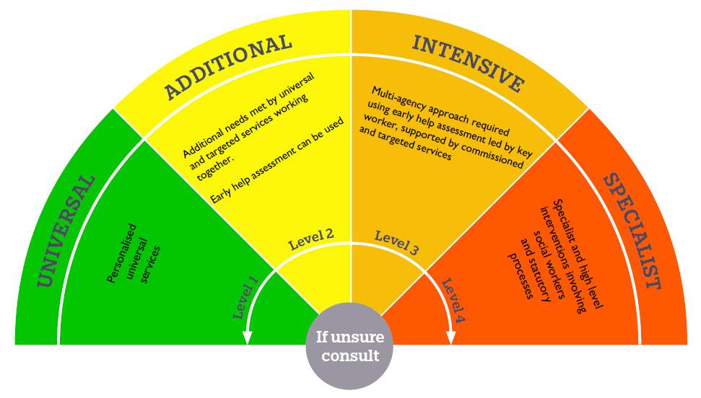

  - This continuum of need forms part of Herefordshire’s threshold guidance, called ‘Herefordshire Right Help Time Levels of Need - A guide to support professional judgement‘ published in November 2020 and is based on providing the right intervention to meet the assessed needs of the child or young person at the point at which they need it. Throughout the electronic version of this document partners will find links to Herefordshire’s policy for each potential indicator, to support decision making for children & families, as well as supporting guidance from alternative sources. The new partnership arrangements are designed to ensure that the responses across this continuum of need are met in an appropriate and timely manner. The approach also promotes early help for families before they reach crisis point and ensures families are supported to help themselves.

  - Throughout the development of these arrangements, the lead partners have recognised their key responsibility in creating the right conditions for all those involved in safeguarding children and young people, in particular those who know the children & families well - including early years settings, schools and colleges, to participate actively in these arrangements and make a difference to the quality and impact of our collective safeguarding work. Their goal is to ensure that the safeguarding arrangements flourish and are highly effective.

Arrangements for commissioning and publishing local child safeguarding practice reviews
  - The Herefordshire Joint Case Review Group deliver the local responsibilities for Child Safeguarding Practice Review as set out in WT2018 (4:7 and 4:15). The group’s Terms of Reference have been updated and a process map and procedures setting out the new processes have been produced.

  - The Joint Case Review Group will be responsible for:
- Initiating the Rapid Review (in accordance with the statutory guidance set out in Working Together 2018) in respect of the incident when informed of a notifiable incident. The Rapid Review will be collated by the Partnership Team Manager and finalised by the Case Review Group and form the basis of advice to the Safeguarding Partners about their recommendation to the Child Safeguarding Practice Review National Panel. Independent advice in respect of each Rapid Review will be available to the Statutory safeguarding Partners through the Independent Chair of the Safeguarding Children’s Partnership.
- Publication of the reviews. This will include publication on the HSCP website in accordance with guidance set out in Chapter 4 Working Together 2018.
- Agreeing and reviewing progress of action plans arising from reviews and for publication and dissemination of practice briefings.

  - The Joint Case Review Group is chaired by the Head of Safeguarding & Designated Nurse for Safeguarding Adults and Children, HWICB and has delegated responsibility as a senior officer, by the Safeguarding Children’s Partnerships ICB Accountable Officer and Chief Nursing Officer. The JCR group Chair provides a quarterly report to the Safeguarding Partners Board or by exception.

The process for undertaking local child safeguarding practice reviews, setting out the arrangements for embedding learning across organisations and agencies
  - HSCP continues to develop a robust approach to learning from cases and undertaking reviews of practice. It will continue to use a variety of methodologies to investigate cases and identify learning, seeking to be proportionate, to close the learning loop and to explore new ways of approaching challenges.

  - The HSCP JCR Group aims to develop and implement a Thematic Learning Framework, which sets a context for practice reviews and provides a consistent approach to addressing learning and seeking best practice.

  - The Members of the JCR group will ensure that learning is disseminated, promoted and embedded within their organisations. They will support the Partnership Team in the development of workshops/webinars and other learning events.

  - The Partnership Team receives all notifications of serious incidents and is responsible for coordinating arrangements for rapid reviews, communication with the National Panel and for the procurement of lead reviewer services for local practice reviews on behalf of the JCR group.

  - The JCR group will be expected to draw on single agency investigations wherever possible and partners will make the learning from these available where appropriate/proportionate through the Rapid Review and Practice Review processes

  - The JCR group will be responsible for delivering local arrangements for the identification of serious child safeguarding cases which raise issues of importance and for commissioning and overseeing the review arrangements for those cases, including the commissioning of lead reviewers, and for the quality control of reports on behalf of the Safeguarding Partners.

  - The JCR group will consider notifications of serious incidents from all partners. It will conduct Rapid Reviews in line with the Practice Guidance issued by the National Panel. The Rapid Review panel will make a recommendation on whether the case meets the criteria for a Child Safeguarding Practice Review. This recommendation will be made to the Statutory Safeguarding Partners who will make a final decision on the commission or not of all case reviews.

  - From experience, Herefordshire learns best when it hears directly from the frontline practice and children. Relevant professionals will continue to be involved in safeguarding practice reviews and their feedback on the process will be monitored and evaluated. The agencies will support any staff involved from a strength based approach to ensure that the emphasis remains on learning rather than blaming, but also addressing any poor practice outside of the process. Children and families will always be considered to contribute and participate in the process.

  - On completion of a review, the report will be signed off by the Statutory Safeguarding Partners prior to publication. The Safeguarding Partners will arrange for leads of agencies and relevant stakeholders who are not core members of the HSCP to be invited to attend any meeting to hear the findings of the report and contribute final views.

  - The learning from these reviews will also be considered by the safeguarding partners who will seek to agree on how to engage with the wider partnership on systemic issues and areas for development in response to the findings and recommendations. The dissemination and embedment of learning will be the responsibility of the three statutory partners with the support of the HSCP Partnership Team.

  - The Independent Author and JCR Chair will work with the Partnership Team Manager and work force development leads to ensure that Herefordshire leaders have the opportunity to reflect on safeguarding practice from the perspective of both their service users and within their workforce.

  - Herefordshire will continue to develop a range of proportionate and effective methodologies to undertake reviews. The HSCP recognises CSPRs are not SCRs by any other name and require a fundamentally different approach – ensuring that learning is quickly identified and disseminated, and that learning between partners and practitioners is strengthened to make the whole children’s system work better.

  - Where cases do not meet the criteria for a child safeguarding practice review, a range of learning options will be developed to ensure that relevant professionals have an opportunity to reflect on the safeguarding system and their own practice

Child Death Reviews
  - Working Together 2018 chapter 5 is a requirement of the Children and Social Work Act 2017 and means that the responsibility for ensuring that reviews are carried out when a child dies, moves from the local safeguarding children boards (LSCBs) to the ICB and the Local Authority.

  - This means that since 2019 there has been new arrangements for child death reviews. The Child Death Overview Panel (CDOP) arrangements will not sit under this new partnership arrangement. In Herefordshire, the geographical and population ‘footprint’ of the new Child Death Review (CDR) Partners has been locally agreed.

  - The CDR Partners for Herefordshire and Worcestershire have formed a joint Child Death Overview Panel which will review all child deaths in those areas.

  - The child death pathway includes a series of multiagency activity, meeting, and representation

  - Joint national reporting has been agreed. In addition, there will be regional themed reviews based on emerging findings from the Herefordshire and Worcestershire Child Death Overview Panel; in conjunction with CDR Partners from Shropshire, Telford and Wrekin, as well as the wider West midlands region, as well as the wider West midlands region. This arrangement provides a better opportunity to learn from the aggregated findings from child deaths. In 2021-22, there were 9 notifications of child deaths in Herefordshire and 34 in Worcestershire.

  - Safeguarding Partners will receive an annual report of the findings from child deaths which will be considered for workforce development and learning and review of policy procedures and services.

How inter-agency learning and development offer will be commissioned, delivered and monitored for impact and how they will undertake any multiagency and interagency audits
  - The HSCP will oversee the delivery of multi-agency training including directing the work of a partnership officer working alongside a pool of multi-agency trainers.

  - All partner agencies have a responsibility to provide a suite of training from their own organisations which will complement the multi-agency safeguarding arrangements and enable practitioners to learn how to effectively safeguard children.

  - Multi-agency training will be based on a Learning and Development Strategy developed through a training needs analysis with partners, overseen on behalf of the Partnership Board by the Development and Practice Group. The training needs analysis will take into account training that is already provided by partners and specific interagency targets , emerging issues or persons who do not otherwise have access to safeguarding learning.

  - The multiagency agency safeguarding training is free for attendees from relevant agencies. The training programme is funded through the contribution of safeguarding partners to the Safeguarding Children’s Partnership business functions, as well as contribution ‘in kind’ through a training pool of staff from partners and agencies.

  - Evaluations of training delivery and of post-training impact on practice is collated and reported on in the Annual Report, and subsequently feeds into the development of the next multiagency Learning and Development Strategy.

  - The partnership will develop a robust system to ensure the impact of training on practice and children’s outcomes is further understood and informs future developments.

  - Training take-up by partners is monitored and will be reported upon in quarterly and Annual Reports.

Audits
  - The Quality and Effectiveness Sub-Group should receive a performance scorecard based principally on the key multi-agency operational safeguarding indicators, based on multi-agency safeguarding arrangements as set out in WT2018. Themes for further enquiry are identified through the analysis of performance data and intelligence, along with issues raised by the Partnership Board or other sub-groups. From these themes and based on learning from serious incidents, an annual programme of multi-agency case audits is developed.

  - For each theme, a random sample of cases are selected, and agencies who have been actively involved are requested to audit their casefile records using a standard template and with discussion with the practitioner. Auditors and/or practitioners’ then meet together to review their audit findings and learn from each other, identifying learning that will be useful to develop practice across the partnership agencies.

  - The child’s voice is captured in each case record and informs all multi-agency auditing processes.

  - Consideration is given to the most appropriate and sensitive way of further gaining the views of children and families involved in the audited cases, for example, who might be best to contact the family, whether such contact would have an impact on on-going child protection or court issues.

  - The outcome of audits are reported to the Quality and Effectiveness group and will be delegated to a task and finish or priority group to ensure the recommendations from the audits are actioned in real time to optimise the learning and embedment into practice.

  - In line with its own learning and development ethos, the HSCP will use opportunities to make links to national development work. It will develop further options for independent scrutiny such as peer review, and will keep a watch on how independent scrutiny develops within the region and across the country under the new arrangements.

Arrangements for independent scrutiny of the effectiveness of the arrangements, how the arrangements are reviewed; how any recommendations are taken forward, and independent scrutiny of the report Safeguarding Partners must publish at least once a year
  - The HSCP is chaired by the Independent Scrutineer.

  - There is good evidence from research nationally and locally that the role of the Independent Chair has added value in terms of independent scrutiny, system leadership, ability to challenge agencies and the ability to support the building and maintenance of good relationships across agencies. The lead partners determined that the role of an independent person should be maintained for specific groups and to support the scrutiny and assurance functions.

  - The Statutory Safeguarding Partners are clear that whilst the role will have some similarities to the previous role of the safeguarding board chair, it will not be the same. The new role is that of the Independent Scrutineer and will provide independent scrutiny, challenge and assurance to the partners in order to ensure that safeguarding for children and young people in Herefordshire and the arrangements that comply with Working Together 2018 are effective and drive and embed high quality practice across all who work with children and young people, their families and carers.

  - The Independent Scrutineer ensures an objective evaluation of the partnership and that the HSCP agreed strategy is effectively undertaken.

HSCP Strategic Plan 2021-24

  - The independent scrutiny function will provide the constructive and critical challenge to the effectiveness of the multi-agency safeguarding arrangements for the HSCP. It is expected that the Independent Scrutineer will have scrutiny of the partnerships core sub-groups.

  - The Independent Scrutineer will be responsible for the review of these arrangements, and for ensuring that the partnership’s methodology for measuring and monitoring the effectiveness of the overall safeguarding arrangements in Herefordshire are robust.

  - Scrutiny will include reviewing and analysing performance data and findings of audits. The Independent Scrutineer will also be expected to analyse the impact of CSPRs, Rapid Reviews (RRs) and what difference they have made to our children and young people.

  - The Independent Scrutineer operates at all levels of the Safeguarding Partnership organisation and for 2023 – 24 will chair the Safeguarding Children’s Partnership Board in addition to specific consultative sessions with the frontline practitioners, children, and young people fora.

  - The regular contact with the business of the HSCP, the development of professional working relationships with key partners, and the resulting depth of local knowledge and understanding means that the independent scrutiny of the effectiveness of the arrangements is ongoing and fully informed.

  - We understand ‘the independent scrutiny of the effectiveness of the arrangements’ to be a high-level overview of safeguarding governance structures, business processes, and in particular safeguarding outcomes achieved. This will be supported by the more detailed scrutiny of the effectiveness of operational safeguarding performance that is delegated from the Safeguarding Children’s Partnership Board to the Quality and Effectiveness Sub-group, as well as scrutiny of individual agency’s compliance with their WT2018 chapter 2 duties.

  - Working Together 2018 specifies that the HSCP must be subject to an independent scrutiny arrangement, produce and publish an annual report on the effectiveness of the multi-agency safeguarding arrangement in Herefordshire. The report will identify weakness, the causes of the weakness and the action taken to address them as well as other proposals for action, recognising achievements made and providing a realistic assessment of the challenges to be overcome. The annual report of effectiveness will also be subject to independent scrutiny.

  - The HSCP is committed to ensuring that the work is properly planned and reviewed and as such will subject the multiagency safeguarding arrangements to annual independent scrutiny

Herefordshire Safeguarding Children Partnership - Herefordshire Safeguarding (herefordshiresafeguardingboards.org.uk) .

Annual Report
22.1 Each year an HSCP Annual Report will be published. It will include:

- evidence of the impact of the work of the safeguarding partners and relevant agencies, including training, on outcomes for children and families from early help to looked-after children and care leavers
- an analysis of any areas where there has been little or no evidence of progress on agreed priorities
- a record of decisions and actions taken by the partners in the report’s period (or planned to be taken) to implement the recommendations of any local and national child safeguarding practice reviews, including any resulting improvements
- ways in which the partners have sought and utilised feedback from children and families to inform their work and influence service provision
- Safeguarding partners will be expected to include a review of the use of restraint where applicable within their establishment in their annual report returns.

  - The annual report will be presented to the Safeguarding Partners own agency governance and accountability bodies namely the Herefordshire’s Children and Families Scrutiny Committee, the Police and Crime Commissioner and the Herefordshire and Worcestershire Integrated Care Board.

  - The HSCP Annual Report will be made publicly available on the each of the Safeguarding Partners organisation websites.

Funding and Business Support and Partnership Team
  - The HSCP is supported by the HSCP Partnership team, which is hosted by Herefordshire Council. Following the co-location and review of the HSCP, HSAB and Herefordshire CSP the partnership has a single revised joint-funded Partnership Team providing support to the three partnerships.

  - The HSCP Partnership Team and MASA is principally funded by the three safeguarding partner agencies these funding arrangements will continue.

  - A budget will be agreed each year and details contained in the Business Plan. Contributions should, wherever possible, be agreed on a rolling three-year basis to allow for forward planning. The figure should be agreed by each agency six months in advance. The HSCP budget may be revised throughout the year at the discretion of the partnership according to the needs of the HSCP to fulfil its functions.

  - Financial Accountability - The role of the Accountable Body is to ensure that financial probity is established and maintained. Herefordshire Children Services will be accountable for all funding received from statutory partners. This includes receipt of the funding, and for setting up and monitoring the financial monitoring systems. The Accountable Body is not by itself responsible for managing the financial operations of the Partnership or for taking decisions regarding allocation of funding. This means that if there is concern about whether funding is being used properly and for the purpose for which it was given, the Accountable Body will have the final decision on a course of action. However, questions about value for money and allocation of resources will be made by the Statutory Safeguarding Partners within the Partnership meetings.

  - Herefordshire Children Services as the Accountable Body will put in place effective arrangements for safeguarding public money, including establishing a clear line of responsibility and accountability and for the production of a finance report at bi-monthly meeting. Lines of accountability are as follows:
Director of Children Services | Accountable Body
Service Director Safeguarding QA | Cost Centre Manager
Partnership Team Manager | Day to Day Management of Budget

  - The current funding is to be reviewed to ensure it is able to sufficiently cover all elements of the children’s multiagency safeguarding arrangements including running costs for the Partnership Team, the independent chair/ scrutineer and the cost of local child safeguarding practice reviews.

  - The HSCP Partnership Team will continue to support with:
- Administration of all HSCP and sub structure meetings
- Co-ordinating RR and CSPR
- Communication, including website maintenance and supporting any campaigns or awareness raising activity
- Training and workforce development
- Multi-agency policy review and updates
- Multi-agency performance data and quality assurance activity; including Service Level Agreements (SLA) with the local authority for performance analyst capacity

  - The HSCP Partnership Team Manager will also be responsible for producing the drafts of any Rapid Review Reports, the Strategic Plan/Annual Scrutiny and Performance Outcomes Framework and reporting to the Partners SPB on progress against milestones, as well as writing the Annual Report on behalf of the three Safeguarding Partners.

  - The detail of partners’ contributions is agreed annually and is published in the Annual Report.

  - Safeguarding Partnership joint-funding principally covers the cost of the Independent Chair/independent scrutiny, the Partnership Team, training programme, events, communications, including website, and any case reviews requiring external support.

Annual Business cycle
A three year strategic plan is developed to translate the safeguarding vision into strategic priorities and more detailed objectives that will guide the work of sub-groups and task groups. These plans are reviewed annually and published on the HSCP website.

Multi-agency Procedures
The HSCP will continue to contribute to the development and use the Regional Child Protection Procedures for West Midlands which are regularly updated and widely disseminated to partner agencies and form the basis for the multi-agency training programme.

Communications
The Safeguarding Partnership will use a range of methods to communicate with partners such as the HSCP website resources, co-produced Safeguarding Events with HWBB, HSAB and Herefordshire CSP, Summits, an annual safeguarding week, including the use of social media and email communications.

Dispute Resolution
  - Herefordshire safeguarding partners and relevant agencies will proactively work together to resolve any disputes locally. In the event that dispute arises all staff, from partners and relevant agencies, will proactively work together to resolve any disputes locally through timely dialogue, discussion and and/or meeting within a timescale as specified within the Resolving Disagreement and Escalation Protocol which outlines referring unresolved concerns to the HCSP Chair.

  - It is the responsibility of each agency representative to adopt the highest standard of professional conduct, and to attempt to resolve any issue close to the organisational level where it arose, through means of a dialogue with the person or agency that brought up the matter.

  - Any public bodies failing to comply with their obligations under law will be held to account through a variety of regulatory and inspection activity.

Risk Assessment
  - There is a risk that the quality of scrutiny and quality assurance could be compromised if arrangements are changed. All partners have agreed that clear principles must be adhered to when considering any future changes. Any changes need to enhance and further strengthen partnership working and safeguarding practice and the priority will be on safety and protection at all times.

  - A second risk is the financial implication of supporting the Multi-agency safeguarding arrangement, as this is key to the effectiveness. This will be mitigated by the three statutory partners addressing all financial matters so it is clear what the expectations would be on all partners who have safeguarding responsibility.

Amendments to Herefordshire’s MASA
This document will be reviewed on an annual basis to ensure that it reflects national and local developments and that it remains relevant.

Any changes to the HCSP multi-agency safeguarding arrangements shall be ratified by the members of the partnership. Any member may request a review of the arrangements by writing their request to the HCSP Chair.

The HCSP Chair on receipt of the request will notify members of the partnership and ensure the matter is placed as an item of the partnerships agenda for full consideration.
The three statutory safeguarding partners will report any updates to the published arrangements in their annual report and the proposed timescale for implementation.

Appendix 1 – schools and education providers in Herefordshire regarded as relevant agencies for local safeguarding arrangements
There are 100 publicly funded primary secondary and special schools in Herefordshire. School directory – Herefordshire Council

See School / Colleges in Herefordshire

Herefordshire’s Pupil Referral Unit Service (PRUs)

Appendix 2 – Early Years providers in Herefordshire regarded as relevant agencies for local safeguarding arrangements – funded providers other than sole traders.
For an up to date list of early years provision please use the following link to the councils directory.
Synergy - Search By Route (herefordshire.gov.uk)

Appendix 3 - HSCP Structure

