A Day in My Life:

To use with children and young people, parents or carers

Case reviews, in Herefordshire and nationally, have found that the daily lived experiences of children and young people were often not understood. This meant that risks were not identified and appropriate support was not provided to families.
The Day in My Life tool can be used in variety of ways to draw out the daily lived experience of the child. This helps to understand what is happening in families where child neglect is a concern, and what actions might lead to improved outcomes for children.
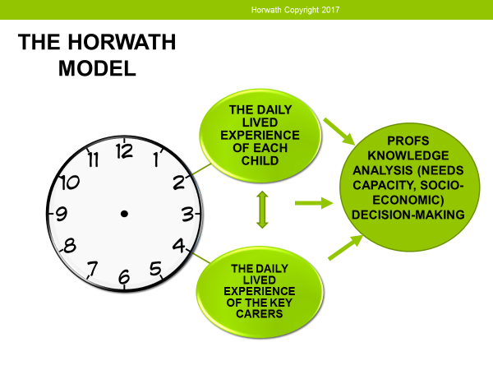
The basis of the tool is to find out what the child does during the day and night and what can make a good or bad day. Parents and carers can also be asked to contribute so that different perspectives are compared. The Day in My Life tool is based on the Horwath Model, which provides a framework for understanding daily routines from the child’s and parents/carers’ experiences, and professionals’ knowledge, and analysing this information to understand the impact on the child.

How do you use it?
This tool is flexible and can be used with different discussion formats and templates.
Talk to children and parents/carers about what a regular day is like in their life across, a 24-hour cycle, and considering weekdays and weekends/ holidays. By talking to each family member and cross-referencing their experiences of the same day, you can make the experience of each child visible.
Using a blank piece of paper, or one of the templates provided, ask the child to show you what each time of day looks like, splitting the page into boxes to represent different parts of the day:
Getting up
Going to school
The school day
After school
Evening / Bath time
Bedtime
There are a set of prompt picture cards provided, that you can use. You could print them out, laminate them and have them available as separate cards. You can ask the child to pick a card and get them to draw, or write, on one of the timeline sheets with what they want to say. You can also use the prompt pictures and assign pictures to “Always – Sometimes – Never” categories (example template provided).
You might also want to bring emojis or feeling faces, so the child can indicate how they feel about certain tasks or times of the day. There are some examples below, or they are easily searched for and downloadable from websites.

Here are some more tips on using the tool:
- Think about each part of the day and come up with as many questions as you can that would help to understand this part of the child’s day.
- Keep in mind that some children say that they find this exercise repetitive and long. Be aware of this, try not to dwell on every detail, and find creative ways of asking open questions.
Closed Question = When do you eat dinner?
Alternative Open Question = What happens in the evenings in your house?
Closed Question = How do you get to school?
Alternative Open Question = Can you tell me what the mornings are like? What happens when you wake up?
- Family life for neglected children can be chaotic. When trying to understand their lived experience, aim to ask open questions, do not take anything for granted and do not presume any degree of routine occurs in the household.
- Consider completing the tool for EACH child in the family.
- Parents could also be asked to talk through each section of their day.
- Parents could be asked to imagine they are their child (or each of their children in turn) and talk through the day as if they were that child. This will draw out how far the parents understands and empathises with the child’s daily experience.
- Each section of the day can be compared to other’s perspectives. So how does the professional perspective of the morning differ from the parent’s or the child’s? Why is this?
- If you have particular areas of concern, focus on asking what is happening for the child at a particular time of the day. (i.e. if you are worried that the child is not going to school, you could ask, “Can you tell me what happens in the mornings when you wake up?”).
- The concept of time can be abstract and easily misunderstood by younger children. When asking younger children to recall their daily lived experience, rather than asking “can you tell me about a morning last week?” you could ask “can you tell me about what happened this morning?”

What happens after Day In My Life is completed?
Once you have completed this activity, reflect on what you have heard and think about the following questions. You may want to use the Summary and Analysis Tool:
- Can you identify what is missing in the care of the child?
- How many dimensions of the child’s needs are being met or are not being met?
- What appears to be the impact of this on the child’s development, presentation or wellbeing?
- Do any changes need to be made and how significant are they?
- How can you verify any information?
Summary and Analysis Tool
What is working well?
What are you worried about?
What is the child or young person’s view of their situation? (If the child is too young to express their views what are your observations of the child within the family setting?)
What is the parent / carer, or other family members’ view of the situation?
What needs to happen? Who will do what? By when?

Always discuss the completed tool with your manager/Designated Safeguarding Lead and follow your own agency’s procedures to either manage the identified support required or to escalate to the Children Help and Advice Team (Early Help Support), or Herefordshire MASH (for safeguarding). Consult the Right Help, Right Time Levels of Need to help determine the level of need for this family, and appropriate response.

Templates and Guides
The following guides and templates have been developed to support a Day in My Life being completed. These templates can be found on the Child Neglect Resources Page of the HSCP website.
- A Day in My Life – Prompt Questions and Areas to Cover
- Daily Timeline Templates – detailed (different templates for different ages)
- Daily Timeline Template – simple “school day”
- Picture prompt cards (different cards for different ages)
- Always Sometimes Never Template
- Good Day Bad Day Template
- Emojis
- Feelings Game
There are also more resources and tools to help practitioners in working with children and families in the HSCP Voice of the Child Participation Toolkit.

